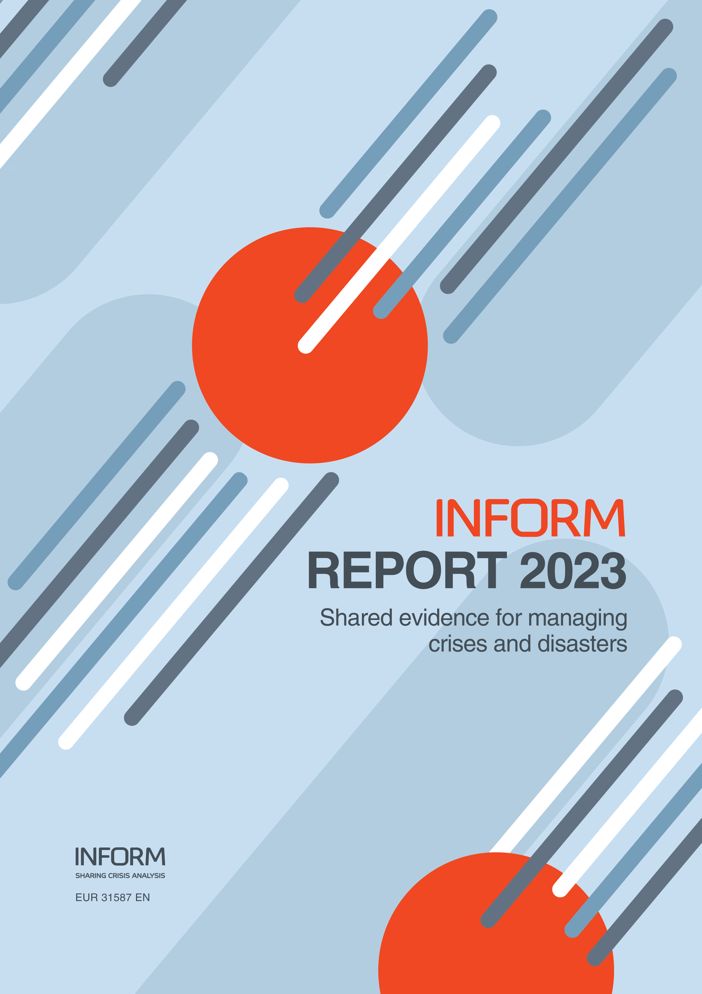

ISSN 1831-9424

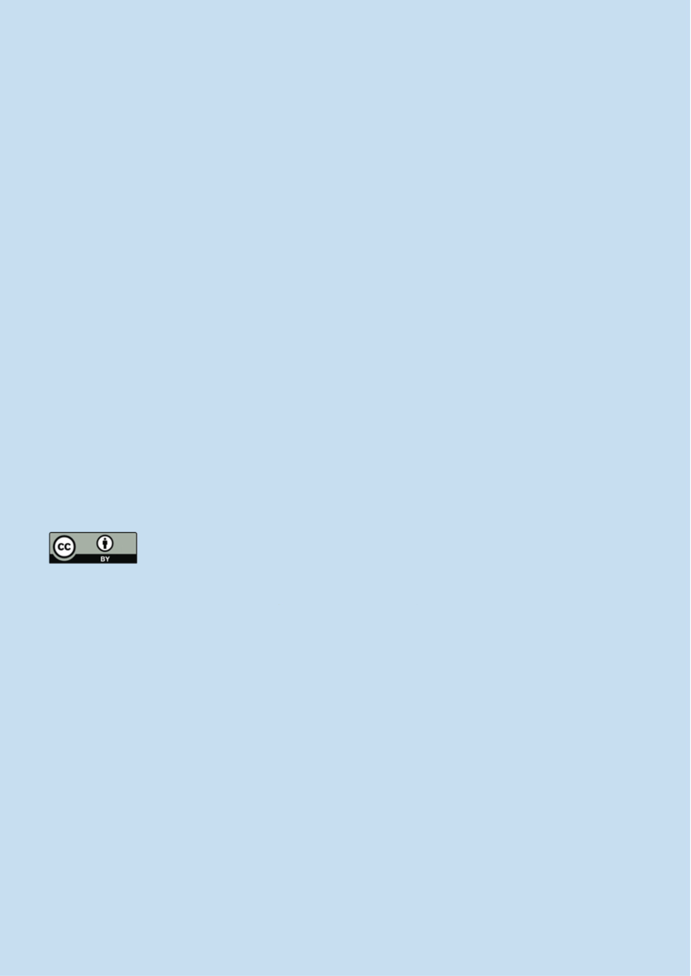

Shared analysis for better decisions

Note: The geographical boundaries and names shown and the designations used in this report are not warranted to be error free nor do they necessarily imply official endorsement or acceptance by INFORM or any INFORM partner organisation. Every effort has been made to ensure the accuracy of the information contained in this report. All information was believed to be correct as of May 2023.

INFORM is a collaboration of the Inter-Agency Standing Committee and the European Commission. This report is produced by the United Nations Office for the Coordination of Humanitarian Affairs on behalf of all INFORM Partners. The Joint Research Centre of the European Commission is the scientific and technical lead of INFORM.

The European Commission support for the production of this publication does not constitute endorsement of the contents, which reflects the views only of the authors, and the Commission cannot be held responsible for any use which may be made of the information contained therein.

For more information see **https://drmkc.jrc.ec.europa.eu/inform-index**

JRC 134138   
EUR 31587 EN

**Welcome to the INFORM 2023 report.**

INFORM partners believe that the availability of shared analysis of crises   
and disasters can lead to better coordination of actors and better outcomes   
for at-risk and affected people. Specifically, INFORM creates a space and   
process for shared analysis that can support joint strategy development,   
planning and action to prevent, prepare for, respond to and recover from   
crises. This can bring together development, humanitarian and other actors   
to manage risk and respond better when crises do occur.

This report sets out INFORM’s vision for a suite of products to support   
decision-making that are easy to use and open to everyone. This vision   
involves bringing scientific rigour to the process of analysing crises and   
pooling expertise to develop shared methodologies. By working together, we   
can reduce the investments required by individual organisations, assure the

|  |  |  |
| --- | --- | --- |
| PDF | ISBN 978-92-68-05372-0 ISSN 1831-9424 doi:10.2760/073809KJ-NA-31-587-EN-N | quality of our analysis and make it available for the common good. |
| INFORM products help improve the quality of evidence for decisions made |

Luxembourg: Publications Office of the European Union, 2023 © European Union, 2023

at every stage of the crisis management cycle from prevention to response.   
In this report, you’ll find the latest results of the INFORM Severity, INFORM   
Risk and INFORM Climate Change indexes, and analysis of past, current   
and potential future global crisis trends.

The reuse policy of the European Commission is implemented by the Commission Decision 2011/833/   
EU of 12 December 2011 on the reuse of Commission documents (OJ L 330, 14.12.2011, p. 39).

Except otherwise noted, the reuse of this document is authorised under the Creative Commons   
Attribution 4.0 International (CC BY 4.0) licence (https://creativecommons.org/licenses/by/4.0/). This   
means that reuse is allowed provided appropriate credit is given and any changes are indicated. For   
any use or reproduction of photos or other material that is not owned by the EU, permission must be   
sought directly from the copyright holders.

All content © European Union, 2023 (unless otherwise specified)

**How to cite this report**   
Inter-Agency Standing Committee and the European Commission, INFORM REPORT 2023; Shared   
evidence for managing crises and disasters, Publications Office of the European Union, Luxembourg,   
2023, doi:10.2760/073809, JRC134138.

**How to obtain EU publications**   
You can view or order EU publications at **[op.europa.eu/en/publications](http://op.europa.eu/en/publications)**. Multiple copies of free   
publications can be obtained by contacting Europe Direct or your local documentation centre   
(**[european-union.europa.eu/contact-eu/meet-us_en](http://european-union.europa.eu/contact-eu/meet-us_en)**).

1

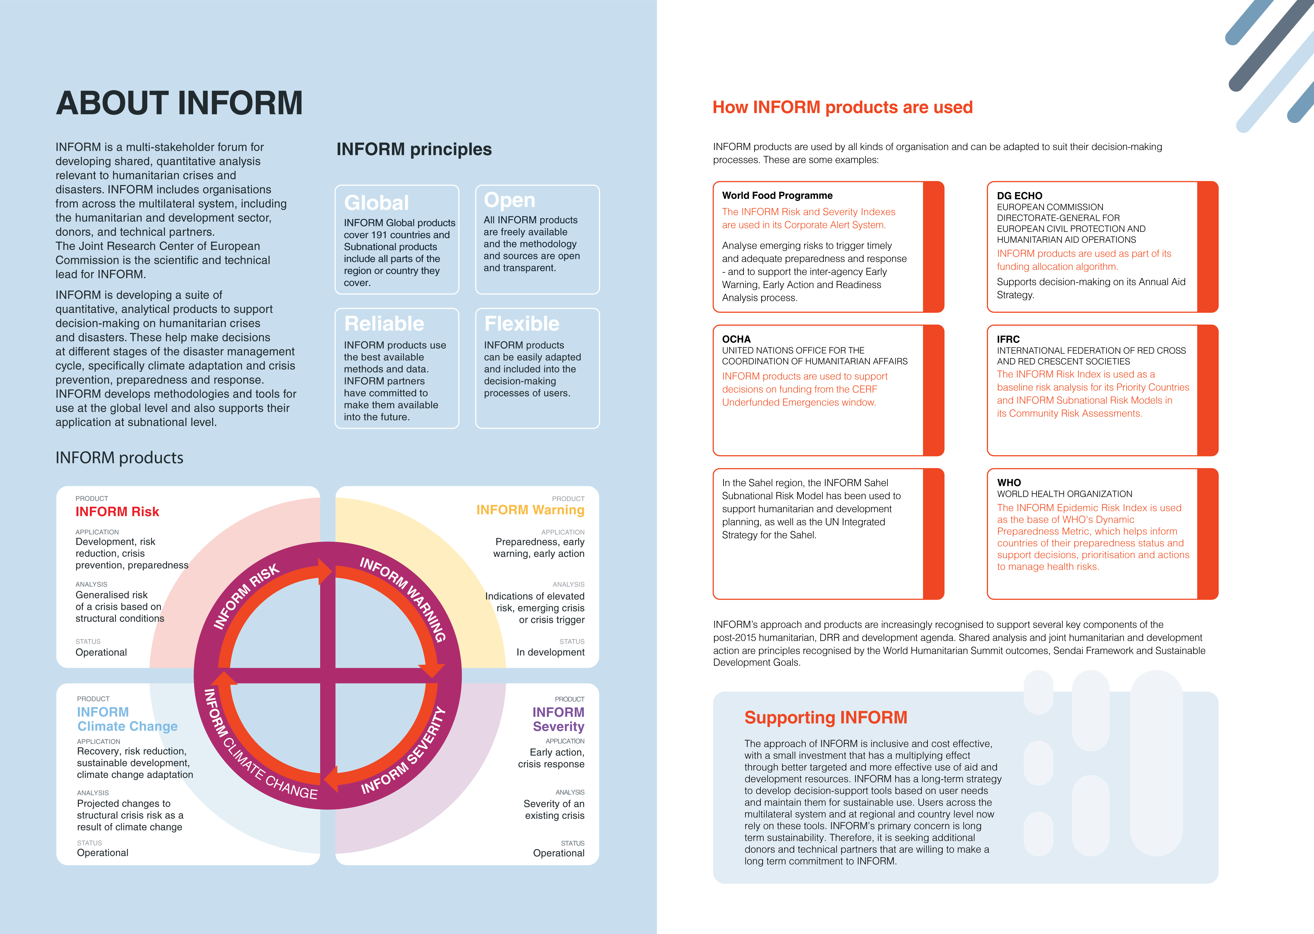

2 3

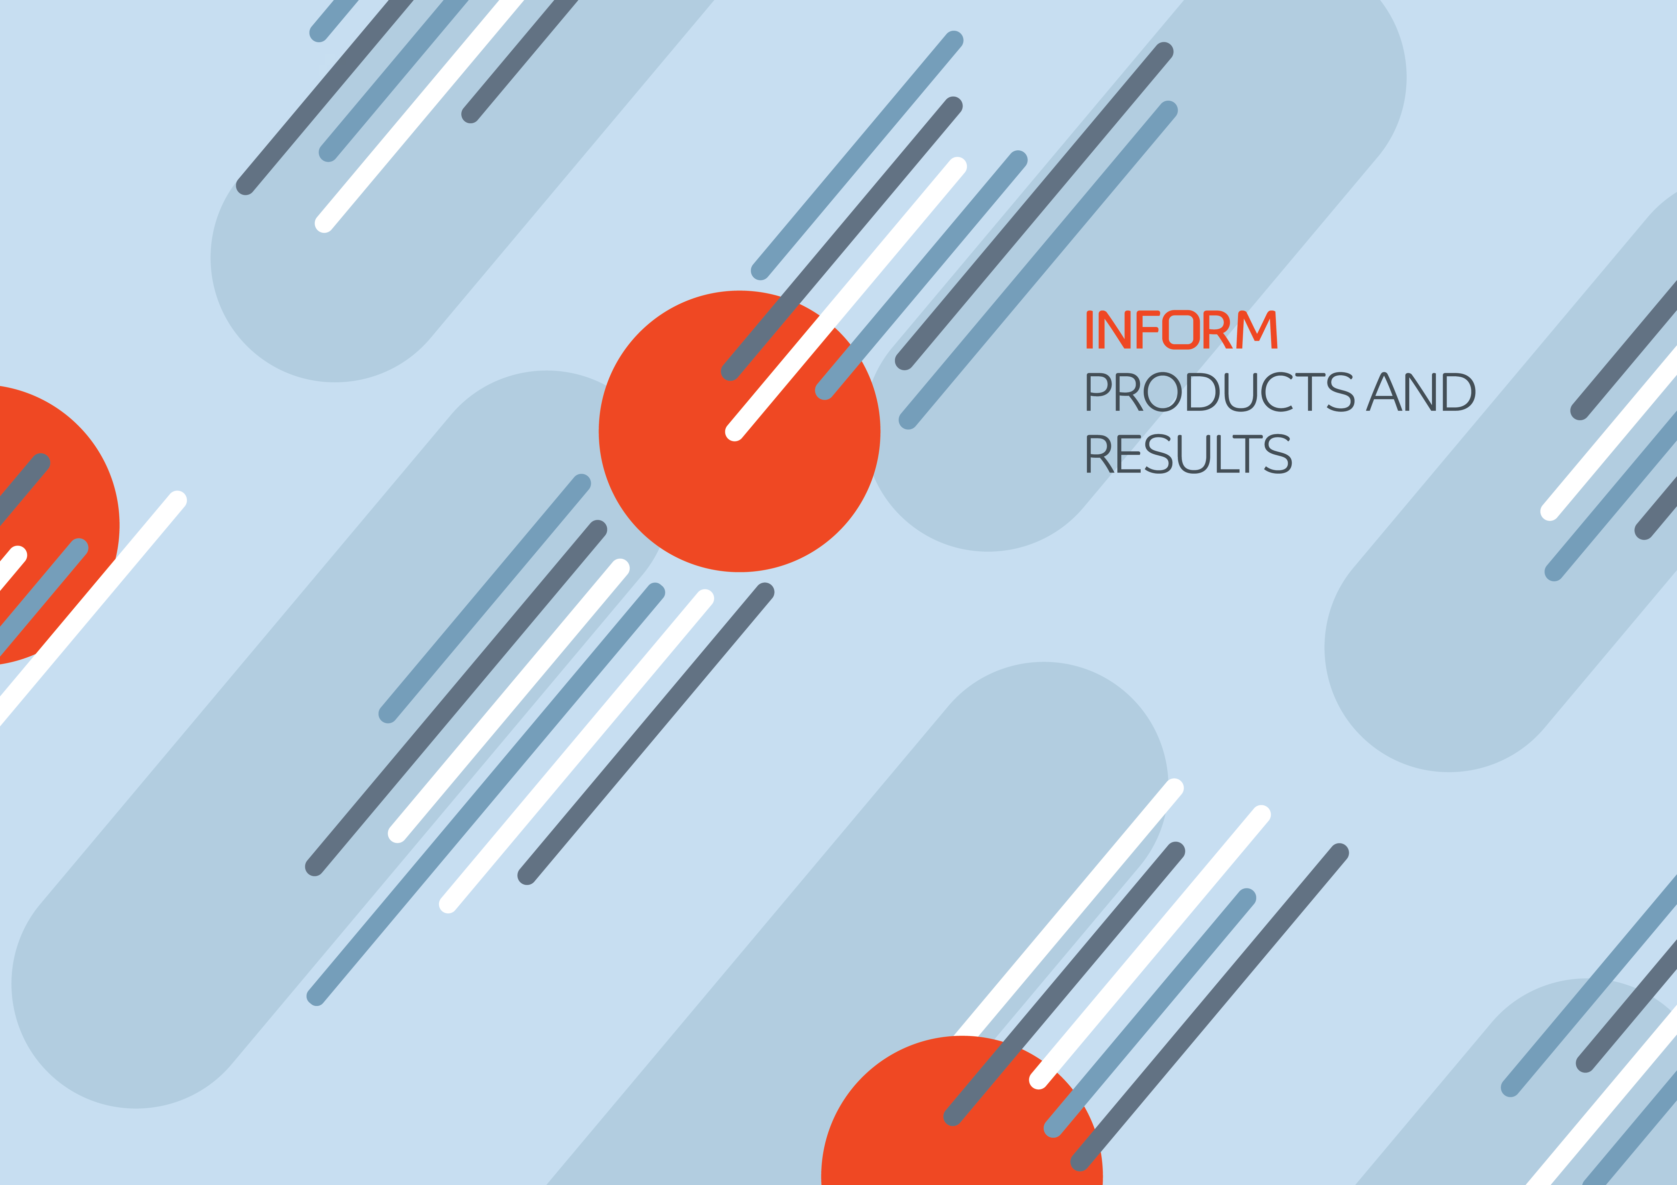



|  |  |  |  |  |  |  |  |  |  |  |  |  |  |  |  |  |  |  |  |  |  |  |  |  |  |  |  |  |  |  |  |  |  |
| --- | --- | --- | --- | --- | --- | --- | --- | --- | --- | --- | --- | --- | --- | --- | --- | --- | --- | --- | --- | --- | --- | --- | --- | --- | --- | --- | --- | --- | --- | --- | --- | --- | --- |
| 6 | **INFORM SEVERITY INDEX** | | | | | | | | | | | | | | **ANALYTICAL FRAMEWORK** | | **RESULTS AND INTERPRETATION** | | | | | | | | | | | | | | | | |
| The INFORM Severity Index summarises a wide | **How it works** | | | | | | | | | | | | | **AND METHODOLOGY** | | The results are provided by crisis. Each crisis | | | | | | | | | | | | | | | | |
| The INFORM Severity Index is a composite indicator that measures the severity of  humanitarian crises against a common scale.  The analytical framework describes how the Index is constructed. Indicators are collected to populate the analytical framework for every crisis and these indicators are used to calculate the Index.  The Index covers:  • The impact of the crisis itself, in terms | | | | | is categorised on a five-level scale from very low to very high severity.  It is also possible to access the values for different levels of the analytical framework, to better understand the main drivers of a crisis. All the underlying data, metadata and methodology are publicly available.  The Index is updated every month and can be used for trend analysis. | | | | | | | | | | | | | |
| range of already existing, quantitative information | | | | | | | | | | | | | |
| about crisis severity and presents it in a format that | 6.3 | | | | 5.7 | | 3.6 | | 2.1 | 5.5 | | 8.0 | 3.0 |
| can be used more easily in decision-making. |
| It aggregates information from a range of credible, | Crisis level | 7.5 | 6.8 | 8.0 | | | | | | | 10.0 | | |
| 6.2 | | | | | | | of the scope and of its geographical, human | | | | | | | | | | | | | | | | | | |
| publicly available sources, such as UN agencies, |
| 4.7 | 2.5 | | | | | | | and physical effects; | | | | | | | | | | | | | | | | | | |
| governments and other multilateral organisations. |
| data | 4.3 | • The conditions and status of the people | | | | | | INFORM Severity | | | | | | Index | INFORM Severity | Index Category | | | INFORM Severity | Index Category |
| Human analysts collect the data and enter it into the | 3.6 |
| affected, including information about the | | | | | |
| Index. |
| 2.1 | distribution of severity (i.e. the number of people | | | | | |
| in each category of severity within a crisis); | | | | | |
| It is intended to lead to a shared and objective  understanding of crisis severity that can support decisions on the allocation of resources and ensure all people affected by crises receive appropriate assistance. | 7.5  4.7 | | | | | | | | | | | | |
| 4.5 | | | | | | 3.4 | | | | | | | • The complexity of the crisis, in terms of factors | | | | | |
| 1.0 | | | | 4.7 | 5.5 | | | | | | | | that affect its mitigation or resolution. | | | | | |
| 7.5 | | | 2.1 | | | 7.5 | 4.5 | | | | | | INFORM Severity Index | | | Complex crisis | | | | | | 4.5 | | | | 5 | | Very High | | | |
| in Afghanistan | | | | | |
| Dimensions | | | | | | | | | | | | | | | | | | |
| Impact | Conditions | Complexity | | Mutliple crises in Bangladesh 2.7 | | | | | | | | | 3 | | Medium | | | |
| **Objectives** | | | | | | | | | | | | | | Rohingya refugee crisis | | | | | | 2.7 | | | 3 | | Medium | | | |
| of people |
| of the crisis | of the crisis | |
| affected | Cyclone Amphan Bangladesh 2.2 | | | | | | | | | 3 | | Medium | | | |
| Human analyst | | | | | | | | | | | | | |
| The overall objective of the INFORM Severity Index is | | | | | | | | | | | | | |
| Categories | | Rohingya Regional Crisis | | | | | | | | | 3.3 | | 4 | | | High | | |
| to measure the severity of humanitarian crises globally | | | | | | | | | | | | | |
| (i.e. between rather than within crises) and on an | | | | | | | | | | | | | | Conflict in Burkina Faso | | | | | | | | | | 3.5 | | | 4 | | | High | | |
| ongoing, up-to-date and regular basis. It seeks to | | | | | | | | | | | | | |
| communicate the current status of crises in a systematic, objective and understandable way. | Impact of the crisis | | | | | | | | | | | | | Complex crisis in Afghanistan | | | | | | | | | | | | | | | | | | |
| In its use - in combination with other sources of | Analytical | | Conditions | | | | | | | | | | |
| information - the INFORM Severity Index is intended to: | INFORM Severity Index | | | | | | | | | | | | | 4 .5 | | | | | |
| framework | | of people affected | | | | | | | | | | | Components | | INFORM Severity Index Category | | | | | | | | | | | 5 | | | | | |
| Extreme | | INFORM Severity Index Category | | | | | | | | | | | Very High | | | | | |
| Lead to a shared and objective | Complexity of the crisis | | | | | | | | | | | | | Impact of the crisis | | | | | | | | | | | 4.9 | | | | | |
| conditions | |
| understanding of crisis severity | | | | | | | | | | | | | |
| Geographical | | | | | | | | | | | | | 4.8 | | | | | |
| Contribute to decisions on the | | | | | | | | | | | | | | Severe | | Human | | | | | | | | | | | 5.0 | | | | | |
| conditions | |
| Conditions of affected people | | | | | | | | | | | | | 4.5 | | | | | |
| Moderate | | People in need | | | | | | | | | | | 5.0 | | | | | |
| conditions | |
| Conditions of people affected | | | | | | | | | | | | | 4.0 | | | | | |
| allocation of resources in a way that is proportionate with crisis severity | Composite  indicator methodology | | | | | | | | | | | | |
| Stressed | | Complexity of the crisis | | | | | | | | | | | 4.2 | | | | | |
| conditions | |
| Justify and advocate for action, | CRISIS 1 | | | | | | Very high | | | | | | | Society and safety | | | | | | | | | | | 3.9 | | | | | |
| None/minimal | | Operating environment | | | | | | | | | | | 4.5 | | | | | |
| conditions | |
| especially in the case of forgotten | INFORM | CRISIS 2 | | | | | Very high | | | | | | |
| or unrecognised crises. |
| Severity | CRISIS 3 | | | | | High | | | | | | | **Using the Severity Index** | | | | | | | | | | | | | | | | | | |
| Index |
| The INFORM Severity Index can be | | It should not be used for decisions | | | | | The INFORM Severity Index is only | | | | | | | | | | | |
| CRISIS 4 | | | | | | | High | | | | | | |
| used to support decisions that require | | about the operational response to a | | | | | | one source of information that can | | | | | | | | | | |
| Monitor trends in crisis severity | CRISIS 5 | | | | | | Medium | | | | | | |
| an understanding of the severity of | | specific crisis. Crisis-specific | | | | support decisions about humanitarian | | | | | | | | | | | | |
| over time. |
| crises globally or to understand | | information like needs assessments | | | | | | crises. It should typically be | | | | | | | | | | |
| CRISIS 6 | | | | | | | Medium | | | | | | |
| changes in crisis severity over time. | | and appeals should be used | | | | complemented by risk, early warning | | | | | | | | | | | | |
| CRISIS 7 | | | | | | | Low | | | | | | |
| to support these decisions. | | | | | | and capacity information. | | | | | | | | | | | | |
| 7 | | | | | | | | | | | | | | | | | | |

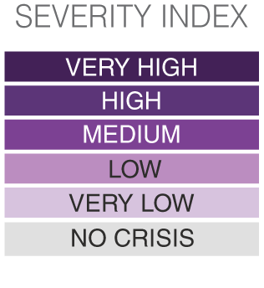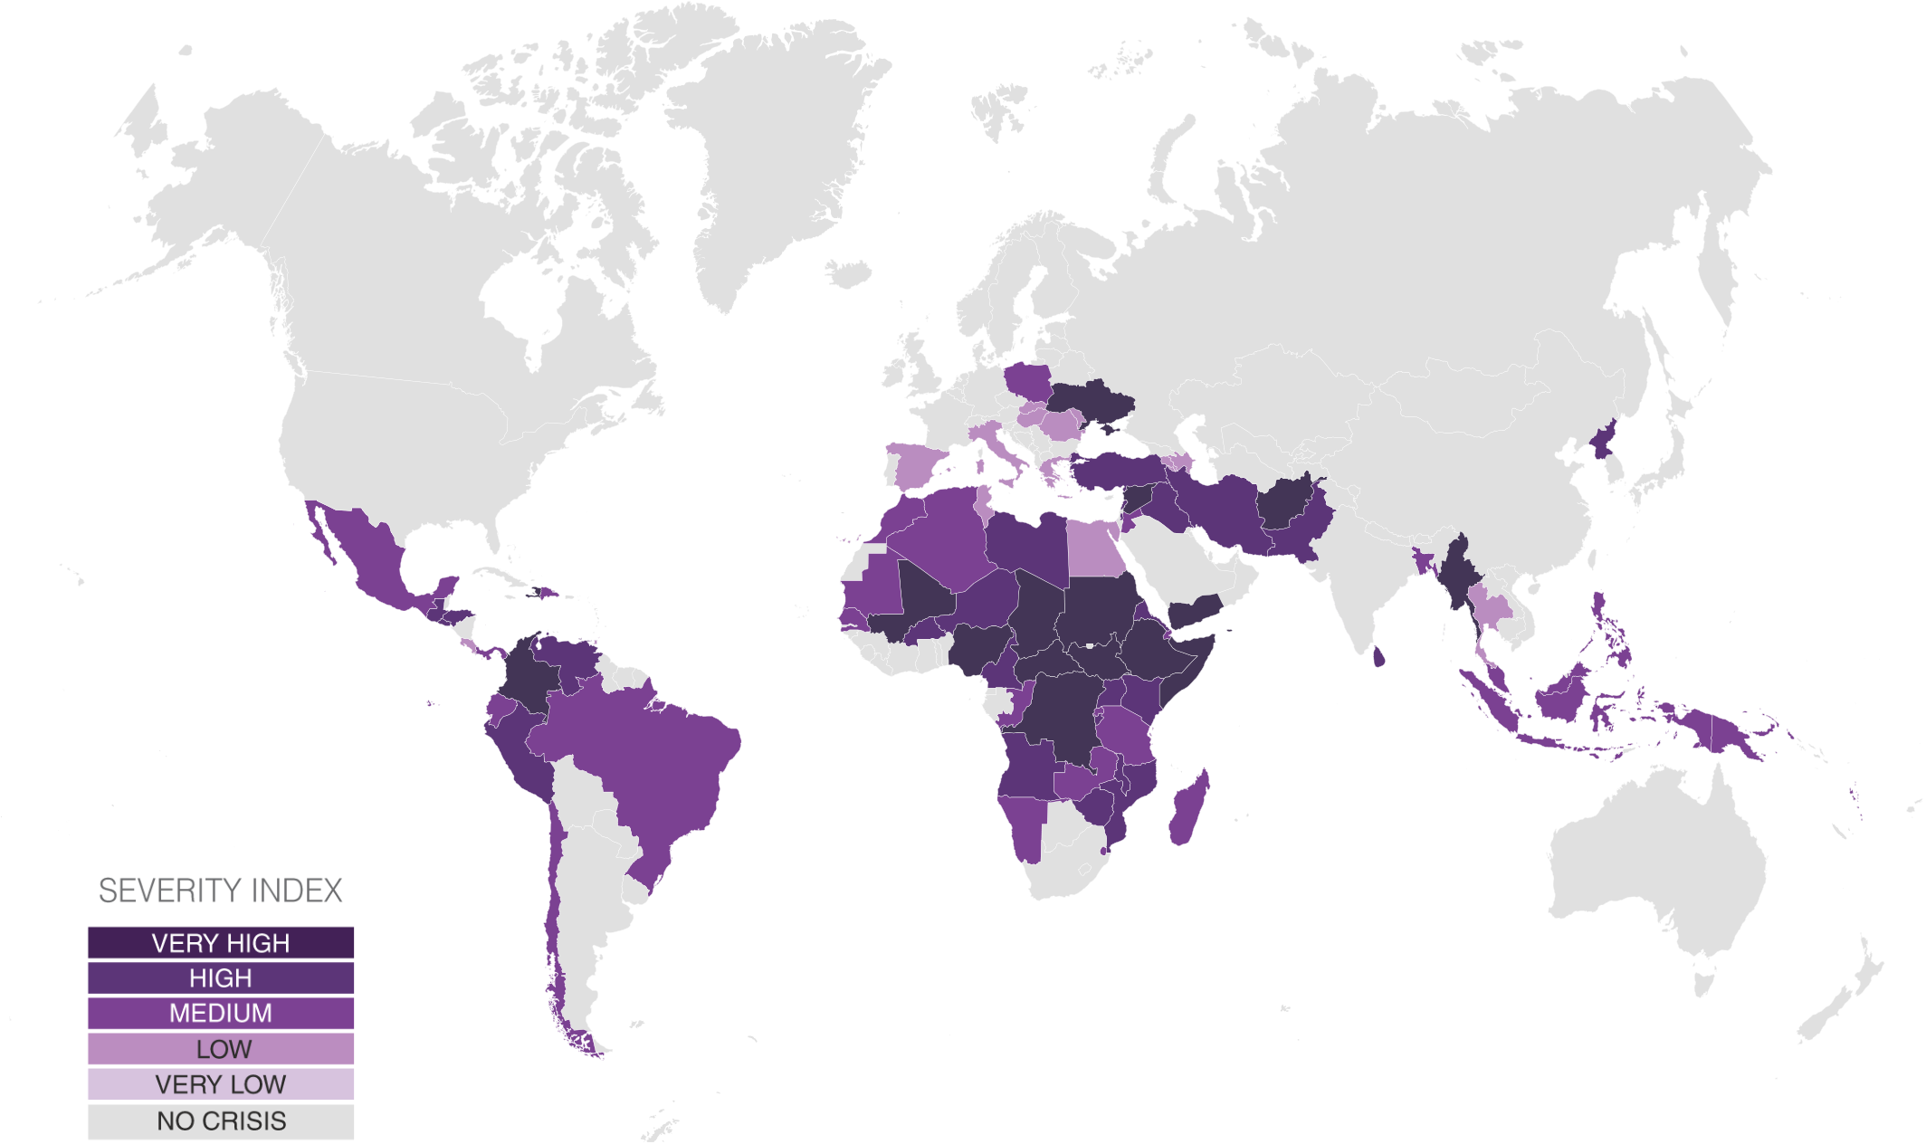

Inform Severity Index results   
**Country level, March 2023**

|  |  |  |  |  |
| --- | --- | --- | --- | --- |
| COUNTRY | CRISIS | SEVERITY  (Country level) | INFORM Severity category | 3 MONTH TREND |
| Afghanistan | Complex crisis in Afghanistan | 4.5 | Very High | Stable |
| Algeria | Multiple crises in Algeria | 2.7 | Medium | Stable |
| Angola | Drought in South-West Angola | 3.1 | High | Decreasing |
| Armenia | Nagorno-Karabakh Conflict in Armenia | 1.1 | Low | Decreasing |
| Azerbaijan | Nagorno-Karabakh conflict in Azerbaijan | 1.8 | Low | Stable |
| Bangladesh | Rohingya refugee crisis | 3.0 | Medium | Stable |
| Brazil | Country level Brazil | 2.7 | Medium | Decreasing |
| Burkina Faso | Conflict in Burkina Faso | 4.0 | High | Increasing |
| Burundi | Complex in Burundi | 3.5 | High | Stable |
| Cameroon | Multiple crises in Cameroon | 4.0 | High | Stable |
| CAR | Complex crisis in CAR | 4.1 | Very High | Stable |
| Chad | Complex crisis in Chad | 4.4 | Very High | Stable |
| Chile | Venezuela displacement in Chile | 2.5 | Medium | Stable |
| Colombia | Complex crisis in Colombia | 4.1 | Very High | Stable |
| Congo | Complex crisis in Congo | 2.2 | Medium | Increasing |
| Costa Rica | Nicaraguan refugees in Costa Rica | 1.5 | Low | Decreasing |
| Djibouti | Multiple crises in Djibouti | 2.7 | Medium | Increasing |
| Dominican Republic | Venezuela displacement in Dominican Republic | 2.2 | Medium | Stable |
| DPRK | Complex crisis in DPRK | 3.7 | High | Stable |
| DRC | Complex crisis in DRC | 4.5 | Very High | Increasing |
| Ecuador | Venezuela displacement in Ecuador | 2.8 | Medium | Stable |
| Egypt | Syrian Refugee Crisis in Egypt | 1.7 | Low | Increasing |
| El Salvador | Complex crisis in El Salvador | 3.1 | High | Decreasing |
| Eritrea | Complex crisis in Eritrea | 3.5 | High | Stable |
| Eswatini | Food Security Crisis in Eswatini | 2.3 | Medium | Stable |
| Ethiopia | Complex crisis in Ethiopia | 4.3 | Very High | Increasing |
| Greece | Mixed migration flows in Greece | 1.4 | Low | Stable |
| Guatemala | Complex crisis in Guatemala | 3.5 | High | Stable |
| Haiti | Complex crisis in Haiti | 4.2 | Very High | Stable |
| Honduras | Complex crisis in Honduras | 3.4 | High | Increasing |
| Hungary | Displacement from Ukraine conflict in Hungary | 1.5 | Low | Decreasing |
| India | Conflict in Jammu and Kashmir | x | x | - |
| Indonesia | Papua Conflict | 2.5 | Medium | Stable |
| Iran | Afghan Refugees in Iran | 3.7 | High | Increasing |
| Iraq | Multiple crises in Iraq | 3.9 | High | Stable |
| Italy | Mixed migration flows in Italy | 2.0 | Low | Stable |
| Jordan | Syrian refugees in Jordan | 2.7 | Medium | Stable |
| Kenya | Multiple crisis in Kenya | 3.7 | High | Decreasing |
| Lebanon | Socioeconomic crisis in Lebanon | 3.4 | High | Decreasing |
| Libya | Complex crisis in Libya | 3.8 | High | Increasing |
| Madagascar | Multiple crisis in Madagascar | 2.9 | Medium | Increasing |
| Malawi | Complex crisis in Malawi | 3.2 | High | Increasing |
| Malaysia | International Refugees in Malaysia | 2.3 | Medium | Stable |
| Mali | Complex crisis in Mali | 4.3 | Very High | Increasing |
| Mauritania | Food Security in Mauritania | 2.7 | Medium | Stable |
| Mexico | Multiple crisis in Mexico | 2.8 | Medium | Stable |
| Moldova | Displacement from Ukraine conflict in Moldova | 1.9 | Low | Decreasing |
| Morocco | Mixed migration flows in Morocco | 2.2 | Medium | Stable |
| Mozambique | Multiple Crises in Mozambique | 3.4 | High | Decreasing |
| Myanmar | Multiple crises in Myanmar | 4.5 | Very High | Increasing |
| Namibia | Food Security Crisis in Namibia | 2.4 | Medium | Stable |
| Nicaragua | Socioeconomic crisis in Nicaragua | x | x | - |

The depiction and use of boundaries are not warranted to be error free nor do they necessarily

|  |  |  |  |  |  |  |  |  |  |  |  |  |  |  |  |  |  |  |  |  |  |  |  |  |  |  |  |  |  |  |  |  |  |  |  |  |  |  |  |  |  |  |  |  |  |  |  |  |  |  |  |  |  |  |  |  |  |  |  |  |  |  |  |  |  |  |  |  |  |  |  |  |  |  |  |  |  |  |  |  |  |  |  |  |  |  |  |  |  |  |  |  |  |  |  |  |  |  |  |  |  |  |  |  |  |  |  |  |  |  |  |  |  |  |  |  |  |  |  |  |  |  |  |  |  |  |  |  |  |  |  |  |  |  |  |  |  |  |  |  |  |  |  |  |  |  |  |  |  |  |  |  |  |  |  |  |  |  |  |  |
| --- | --- | --- | --- | --- | --- | --- | --- | --- | --- | --- | --- | --- | --- | --- | --- | --- | --- | --- | --- | --- | --- | --- | --- | --- | --- | --- | --- | --- | --- | --- | --- | --- | --- | --- | --- | --- | --- | --- | --- | --- | --- | --- | --- | --- | --- | --- | --- | --- | --- | --- | --- | --- | --- | --- | --- | --- | --- | --- | --- | --- | --- | --- | --- | --- | --- | --- | --- | --- | --- | --- | --- | --- | --- | --- | --- | --- | --- | --- | --- | --- | --- | --- | --- | --- | --- | --- | --- | --- | --- | --- | --- | --- | --- | --- | --- | --- | --- | --- | --- | --- | --- | --- | --- | --- | --- | --- | --- | --- | --- | --- | --- | --- | --- | --- | --- | --- | --- | --- | --- | --- | --- | --- | --- | --- | --- | --- | --- | --- | --- | --- | --- | --- | --- | --- | --- | --- | --- | --- | --- | --- | --- | --- | --- | --- | --- | --- | --- | --- | --- | --- | --- | --- | --- | --- | --- | --- | --- | --- | --- | --- |
| imply official endorsement or acceptance by the United Nations and European Union.  Very Low Low Medium High Very High No Crisis Severity Index   |  |  |  |  |  | | --- | --- | --- | --- | --- | | COUNTRY | CRISIS | SEVERITY  (Country level) | INFORM Severity category | 3 MONTH TREND | | Niger | Multiple crises in Niger | 3.9 | High | Increasing | | Nigeria | Complex crisis in Nigeria | 4.1 | Very High | Stable | | Pakistan | Complex crisis in Pakistan | 3.8 | High | Stable | | Palestine | Conflict in Palestine | 3.5 | High | Stable | | Panama | Venezuela displacement in Panama | 2.3 | Medium | Stable | | Papua New Guinea | Highlands Violence | 2.6 | Medium | Decreasing | | Peru | Venezuela displacement in Peru | 3.2 | High | Stable | | Philippines | Multiple crises in the Philippines | 2.6 | Medium | Decreasing | | Poland | Displacement from Ukraine conflict in Poland | 2.5 | Medium | Decreasing | | Romania | Displacement from Ukraine conflict in Romania | 1.4 | Low | Decreasing | | Rwanda | Burundi and DRC refugees in Rwanda | 2.4 | Medium | Stable | | Senegal | Drought in Senegal | 2.4 | Medium | Stable | | Slovakia | Displacement from Ukraine conflict in Slovakia | 1.8 | Low | Decreasing | | Somalia | Complex crisis in Somalia | 4.7 | Very High | Increasing | | South Sudan | Complex crisis in South Sudan | 4.4 | Very High | Stable | | Spain | Mixed migration flows in spain | 1.8 | Low | Stable | | Sri Lanka | Socio-economic crisis in Sri Lanka | 3.4 | High | Stable | | Sudan | Complex crisis in Sudan | 4.4 | Very High | Stable | | Syria | Syrian conflict | 4.6 | Very High | Stable | | Tanzania | International Displacement in Tanzania | 2.6 | Medium | Stable | | Thailand | Multiple situations in Thailand | 1.8 | Low | Stable | | Trinidad and Tobago | Venezuelan refugees in Trinidad and Tobago | 2.0 | Low | Stable | | Tunisia | Mixed migration flows in Tunisia | 1.8 | Low | Stable | | Türkiye | Complex situation in Turkey | 3.4 | High | Increasing | | Uganda | International Displacement in Uganda | 3.2 | High | Stable | | Ukraine | Conflict in Ukraine | 4.1 | Very High | Increasing | | Vanuatu | Cyclone Judy and cyclone Kevin in Vanuatu | 2.2 | Medium | - | | Venezuela | Complex crisis in Venezuela | 4.0 | High | Stable | | Yemen | Conflict in Yemen | 4.7 | Very High | Stable | | Zambia | Drought in Zambia | 2.9 | Medium | Stable | | Zimbabwe | Complex crisis in Zimbabwe | 3.5 | High | Decreasing | |

8 9

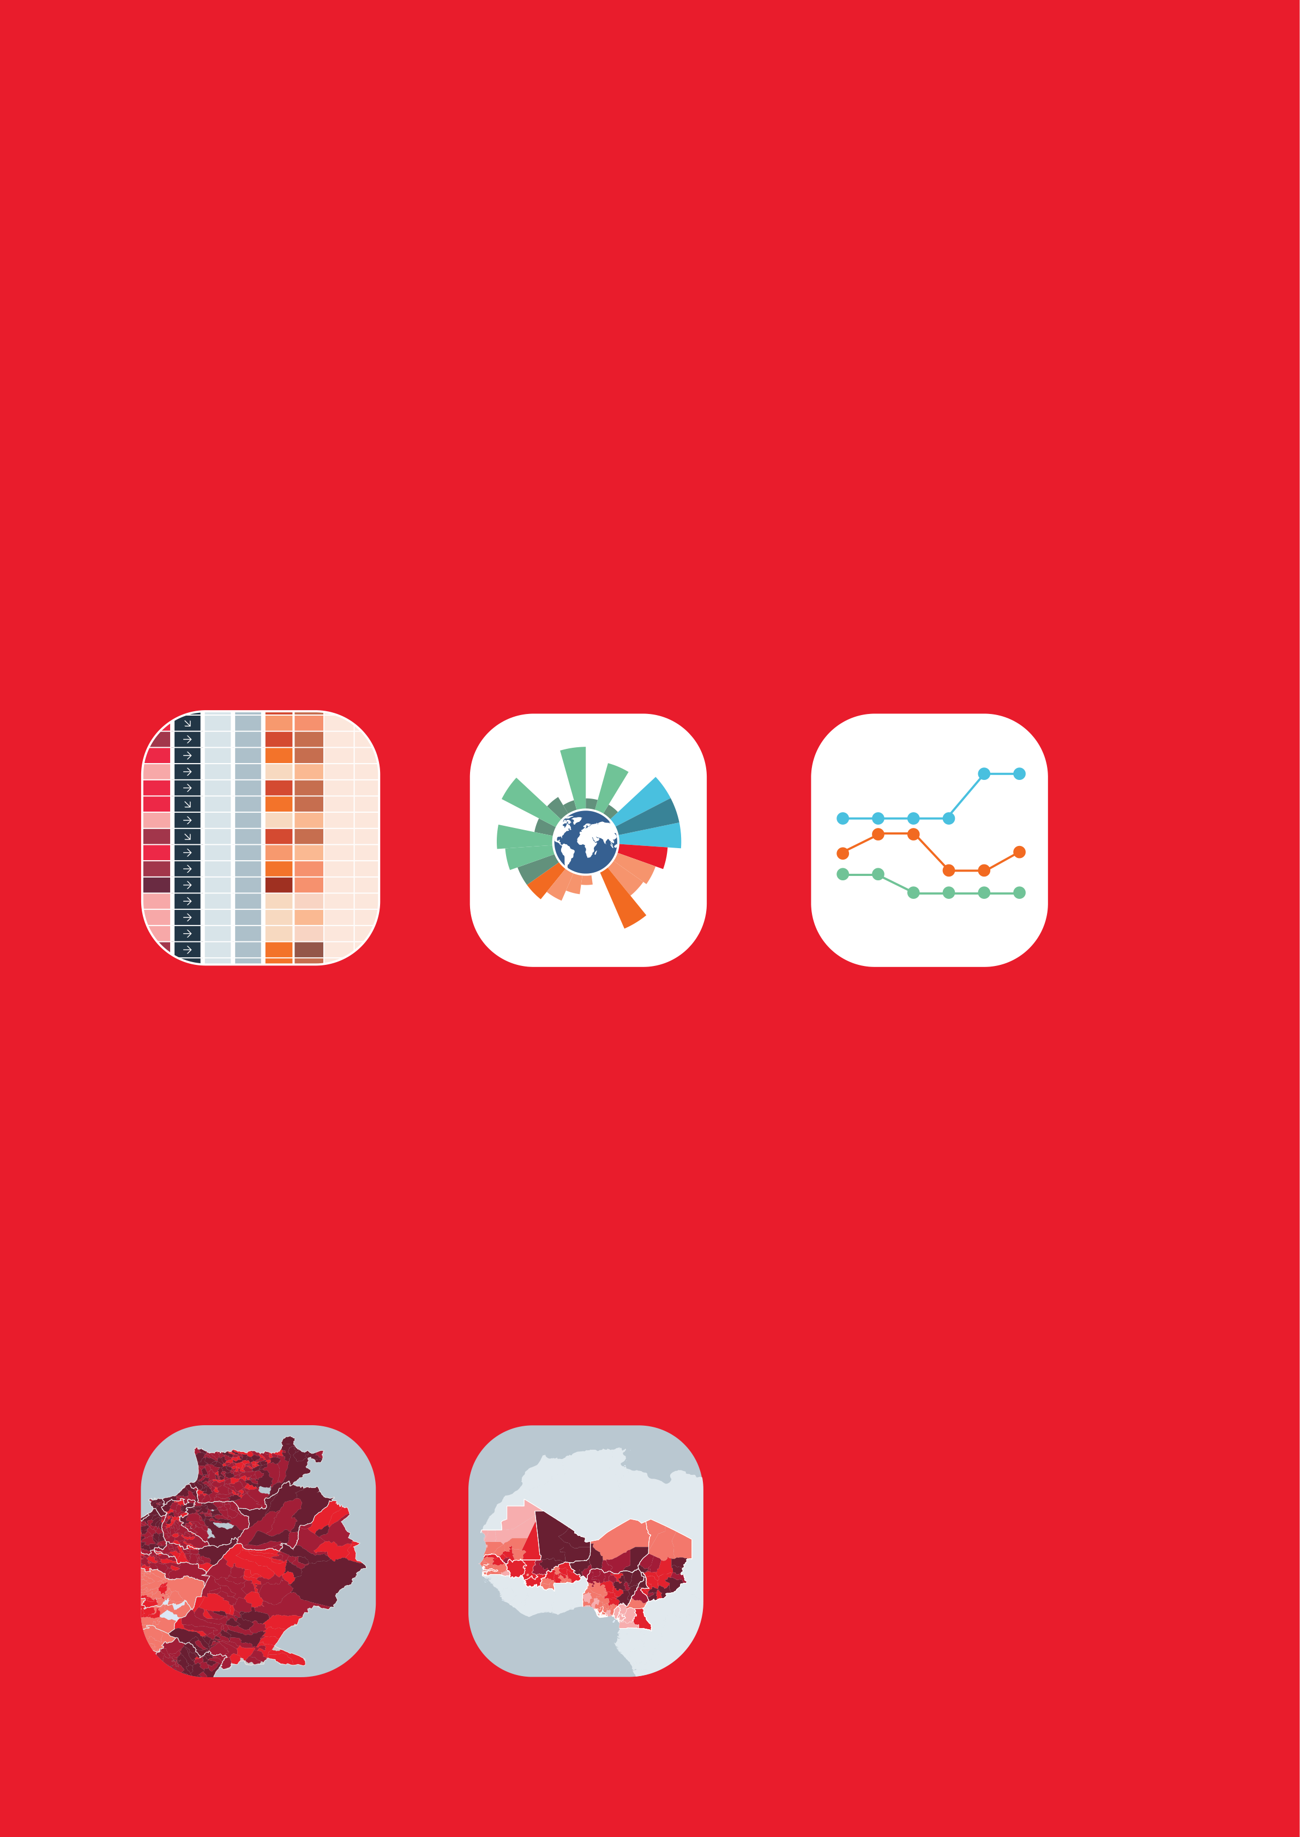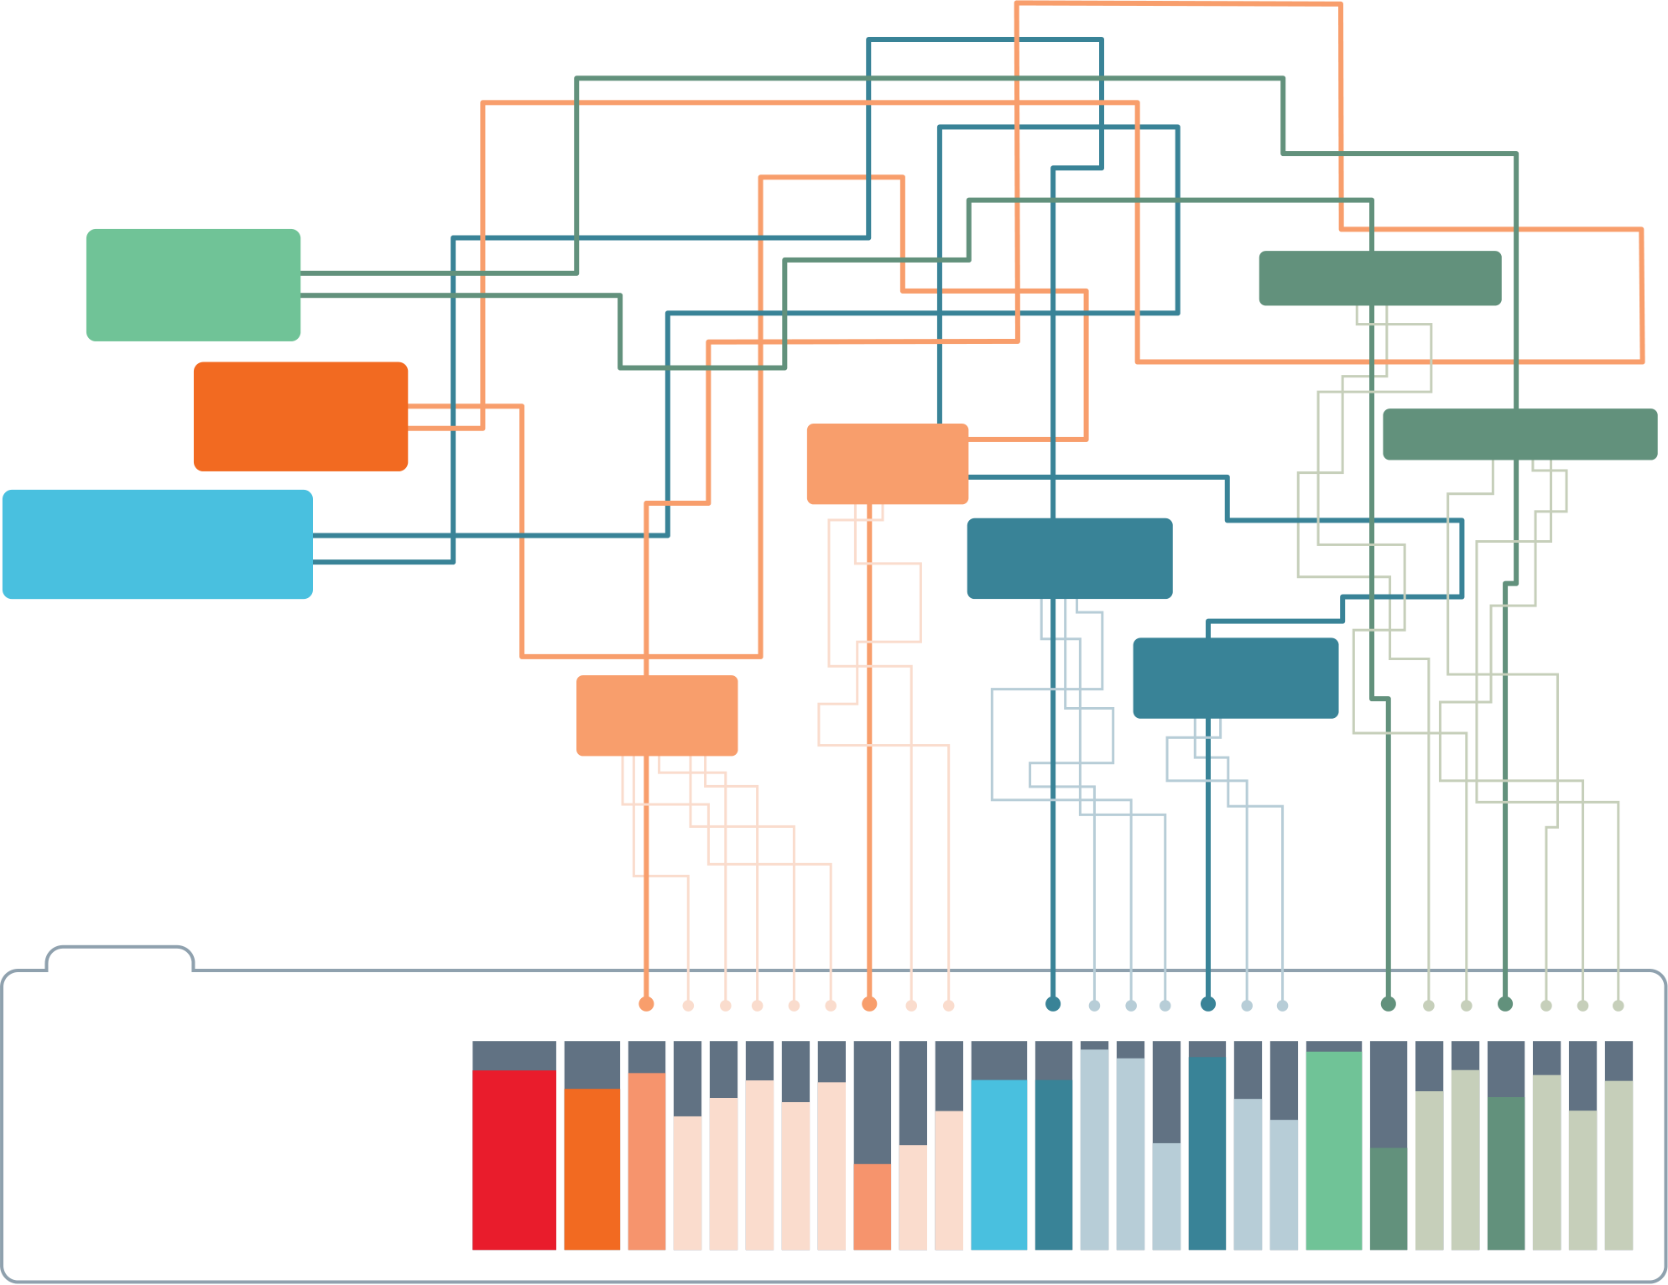

|  |  |  |
| --- | --- | --- |
| **INFORM RISK INDEX** | **How it works** | **INSTITUTIONAL** |
| The INFORM Risk Index is the first global, objective and | **COPING** |
| **CAPACITY** |

transparent tool for understanding the risk of humanitarian crises

|  |  |  |  |  |  |  |  |  |  |  |  |  |
| --- | --- | --- | --- | --- | --- | --- | --- | --- | --- | --- | --- | --- |
| and disasters. It can help identify where and why a crisis might | | | | | | | | | **Monitor** | **HAZARD** | **NATURAL** | **INFRASTRUCTURE** |
| occur, which means we can reduce the risk, build peoples’ | | | | | | | | |
| **HAZARDS** | | |
| resilience and prepare better for when crises do happen. | | | | | | | | |
| **Use INFORM Risk** | | | | | | | | | **VULNERABILITY** | **SOCIO-** **ECONOMIC** | |
| The INFORM Risk Index simplifies | **VULNERABLE** | |
| a lot of information about risk. | **HUMAN** | **GROUPS** |
| It uses 80 different indicators to | **HAZARDS** | |
| measure hazards and peoples’ | | |
| exposure to them, vulnerability, | | |
| and the resources available to | | |
| 3.6 | 99 | 6.6 | | 2.1 | 3.8 | 0.1 | 0.1 | | help people cope. | | |
| 5.4 | 29 | 6.3 | | 4.5 | 5.2 | 4.9 | 7.4 | | The INFORM Risk Index | | |
| 2.1 | 150 | | 4.8 | 3.7 | 5.9 | 7.3 | 4.7 | |
| 1.8 | 161 | | 3.8 | 1.2 | 1.6 | 0.2 | 1.3 | |
| 3.5 | 100 | | 2.0 | 4.5 | 5.1 | 8.6 | 5.6 | |
| 4.0 | 79 | 2.9 | | 3.0 | 4.9 | 3.1 | 9.1 | |
| 1.5 | 174 | | 4.3 | 1.2 | 2.1 | 0.1 | 6.5 | | creates a risk profile for every | | |
| 5.0 | 47 | 3.3 | | 4.6 | 5.2 | 9.6 | 1.2 | |
| 4.3 | 69 | 2.2 | | 1.9 | 2.5 | 0.1 | 3.0 | | country. Each has a rating | | |
| 5.1 | 41 | 2.5 | | 2.8 | 4.0 | 0.1 | 6.2 | | between **0** and **10** for risk | | |
| 6.6 | 12 | 5.8 | | 8.2 | 3.7 | 1.9 | 2.6 | |
| 0.8 | 190 | | 5.2 | 0.7 | 1.3 | 5.2 | 0.1 | | and all of its components, | | |
| 1.4 | 176 | | 4.8 | 0.9 | 1.7 | 0.1 | 4.7 | | so it’s easy to compare. | | |
| 0.9 | 187 | | 4.1 | 0.4 | 0.8 | 0.2 | 2.0 | |
| 5.2 | 34 | 2.4 | | 3.8 | 6.1 | 0.1 | 7.2 | | **Components of risk covered by the INFORM Risk Index** | | |
| 4 8 | 52 | 1 3 | | 2 9 | 4 5 | 6 5 | 5 3 | |
| **Prioritise**  **countries by risk**, or any of its | | | | | | | | Decide how |
| best to  **reduce risk** |  | INFORM RISK INDEX | | |
| risk trends |
|  | **DIMENSIONS** | | |
| components | | | | | | | | |
|  | Hazard and exposure | |  | | --- | | Vulnerability | | |  | | --- | | Lack of coping capacity | |

**CATEGORIES**

|  |  |  |  |  |  |  |  |  |  |  |
| --- | --- | --- | --- | --- | --- | --- | --- | --- | --- | --- |
|  |  | Natural | |  | | --- | | Human | | |  | | --- | | Socio- | | Vulnerable | |  | | --- | | Institutional | | Infrastructure |
| economic | groups |
| **INFORM Risk is adaptable** | **Results and limitations** |  |  | **COMPONENTS** | |  |  |
|  |  | Earthquake | Current conflict | Development and | Uprooted | DRR | Communication |
| **of INFORM RISK** |
| for your organisation or region and the same methodology |
| intensity | deprivation (50%) | people |
| can be used for national and regional risk assessment. |
|  | The INFORM Risk Index is a | Tsunami | Projected | Inequality (25%) | Other vulnerable groups | Governance | Physical |
| conflict risk | infrastructure |

composite index, which is a

|  |  |  |  |
| --- | --- | --- | --- |
| simplified view of reality. Therefore, | Drought | Aid | Access to |
| it should be used in conjunction with | dependency (25%) | health system |

other sources of information. Full   
details of the methodology and a Flood

more detailed discussion of its

|  |  |
| --- | --- |
| limitations are available on the  website. | Tropical cyclone |

|  |  |  |
| --- | --- | --- |
|  | | |
| 6 | Epidemic | 11 |

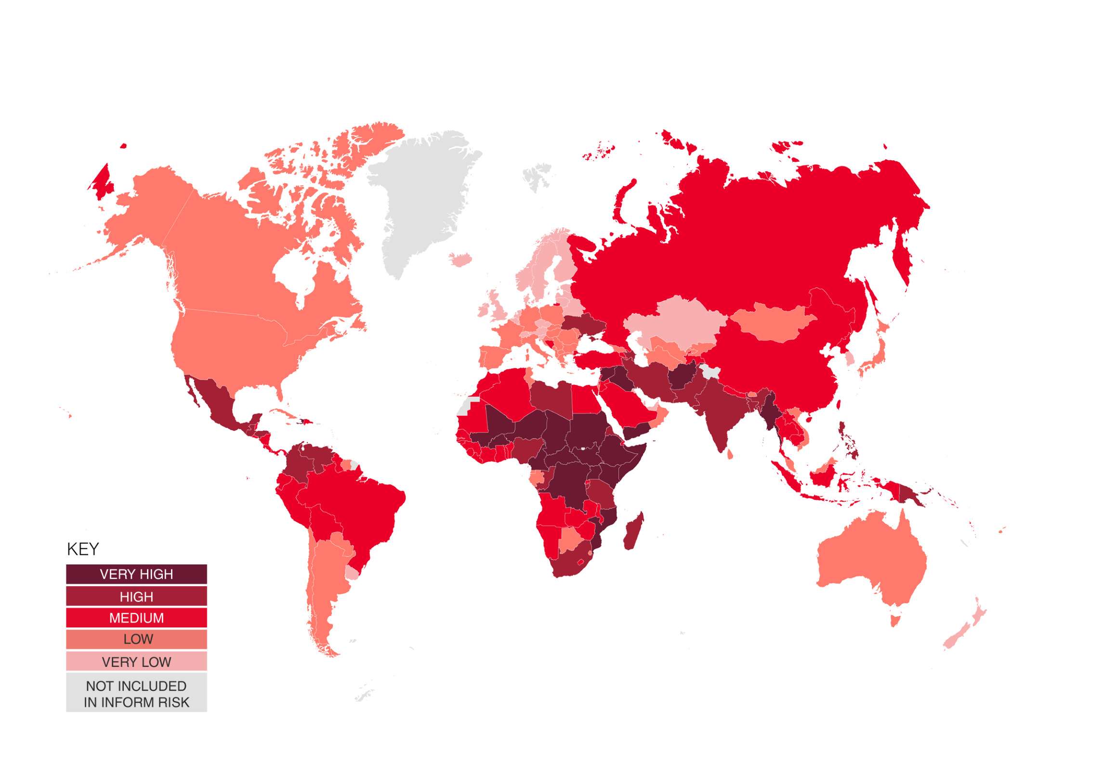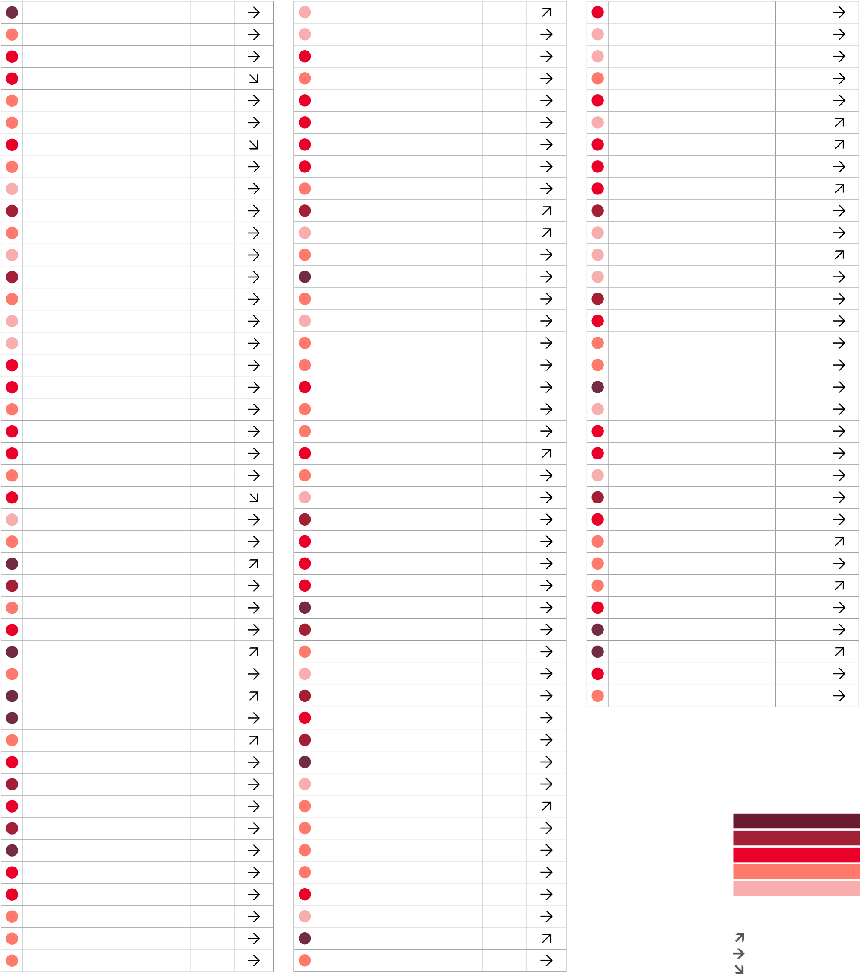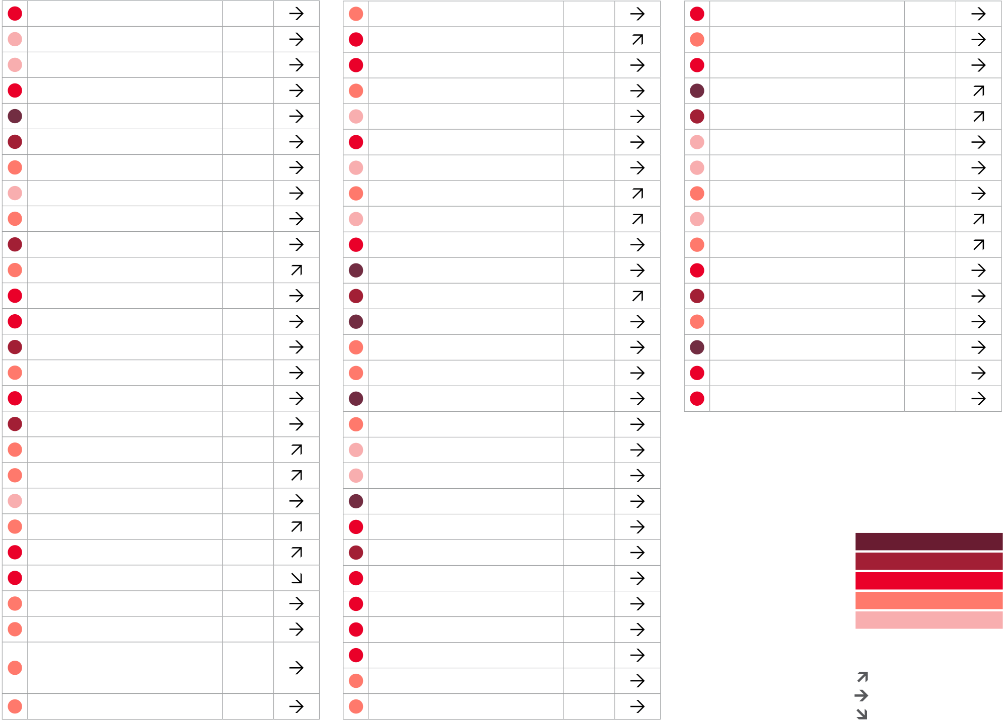

INFORM Risk Index 2023 results

|  |  |  |  |  |  |  |  |  |
| --- | --- | --- | --- | --- | --- | --- | --- | --- |
| COUNTRY | RISK | 3 YR | COUNTRY | RISK | 3 YR | COUNTRY | RISK | 3 YR |
| TREND | TREND | TREND |

|  |  |  |  |  |  |  |  |  |  |  |  |  |  |  |  |
| --- | --- | --- | --- | --- | --- | --- | --- | --- | --- | --- | --- | --- | --- | --- | --- |
| 12 | Afghanistan | 8.1 | Czech Republic | 1.8 | Korea DPR | 4.3 | The depiction and use of boundaries are not warranted to be error free nor do they necessarily | | | | | | COUNTRY | RISK | 3 YR |
| Albania | 3.1 | Denmark | 1.2 | Korea Republic of | 1.9 |
| Algeria | 3.6 | Djibouti | 4.8 | Kuwait | 1.8 |
| Angola | 4.6 | Dominica | 3.1 | Kyrgyzstan | 3.1 |
| Antigua and Barbuda | 2.2 | Dominican Republic | 4.1 | Lao PDR | 3.9 |
| Argentina | 2.9 | Ecuador | 4.6 | Latvia | 1.9 |
| Armenia | 4.6 | Egypt | 4.7 | Lebanon | 4.5 |
| Australia | 2.4 | El Salvador | 4.3 | Lesotho | 3.9 |
| Austria | 1.9 | Equatorial Guinea | 3.4 | Liberia | 4.7 |
| Azerbaijan | 5.8 | Eritrea | 6.2 | Libya | 6.2 |
| Bahamas | 2.1 | Estonia | 1.3 | Liechtenstein | 0.8 |
| Bahrain | 1.2 | Eswatini | 3.3 | Lithuania | 1.7 |
| Bangladesh | 5.5 | Ethiopia | 7.0 | Luxembourg | 1.0 |
| imply official endorsement or acceptance by the United Nations and European Union. | | | | | |
| Barbados | 2.0 | Fiji | 2.7 | Madagascar | 5.3 | COUNTRY | RISK | 3 YR | COUNTRY | RISK | 3 YR |
| Belarus | 1.8 | Finland | 0.9 | Malawi | 4.6 |
| Belgium | 1.7 | France | 2.3 | Malaysia | 3.0 |
| TREND | TREND | TREND |
| Belize | 3.9 | Gabon | 3.1 | Maldives | 2.4 | Nepal | 4.4 | Sao Tome and Principe | | 2.6 | | Türkiye | 4.7 | |
| Benin | 3.8 | Gambia | 3.7 | Mali | 6.9 |
| Netherlands | 1.5 | Saudi Arabia | | 3.5 | | Turkmenistan | 2.7 | |
| Bhutan | 3.1 | Georgia | 3.4 | Malta | 1.9 |
| New Zealand | 1.6 | Senegal | | 4.2 | | Tuvalu | 3.5 | |
| Bolivia | 4.0 | Germany | 2.1 | Marshall Islands | 3.8 | Nicaragua | 4.4 | Serbia | | 2.8 | | Uganda | 7.1 | |
| Bosnia and Herzegovina | 3.5 | Ghana | 3.6 | Mauritania | 4.9 | Niger | 7.5 | Seychelles | | 1.9 | | Ukraine | 5.1 | |
| Botswana | 2.9 | Greece | 2.8 | Mauritius | 2.1 |
| Nigeria | 6.4 | Sierra Leone | | 4.4 | | United Arab Emirates | 1.7 | |
| Brazil | 4.5 | Grenada | 1.9 | Mexico | 5.1 |
| North Macedonia | 2.5 | Singapore | | 0.5 | | United Kingdom | 1.9 | |
| Brunei Darussalam | 1.8 | Guatemala | 5.1 | Micronesia | 3.6 | Norway | 0.9 | Slovakia | | 2.2 | | United States of America | 3.2 | |
| Bulgaria | 2.7 | Guinea | 4.6 | Moldova Republic of | 3.4 | Oman | 2.6 | Slovenia | | 1.6 | | Uruguay | 1.8 | |
| Burkina Faso | 7.0 | Guinea-Bissau | 3.8 | Mongolia | 2.6 |
| Pakistan | 6.1 | Solomon Islands | | 4.5 | | Uzbekistan | 3.4 | |
| Burundi | 6.0 | Guyana | 3.7 | Montenegro | 2.7 |
| Palau | 3.3 | Somalia | | 8.7 | | Vanuatu | 4.2 | |
| Cabo Verde | 2.4 | Haiti | 6.5 | Morocco | 3.5 | Palestine | 4.6 | South Africa | | 5.3 | | Venezuela | 5.0 | |
| Cambodia | 4.4 | Honduras | 5.1 | Mozambique | 7.2 | Panama | 3.9 | South Sudan | | 8.5 | | Viet Nam | 3.4 | |
| Cameroon | 6.5 | Hungary | 2.0 | Myanmar | 6.8 |
| Papua New Guinea | 5.9 | Spain | | 2.3 | | Yemen | 8.1 | |
| Canada | 2.4 | Iceland | 1.4 | Namibia | 4.0 |
| Paraguay | 2.6 | Sri Lanka | | 3.3 | | Zambia | 4.3 | |
| Central African Republic | 8.5 | India | 5.3 | Nauru | 3.2 | Peru | 4.8 | Sudan | | 7.1 | | Zimbabwe | 4.5 | |
| Chad | 7.9 | Indonesia | 4.6 | RISK INDEX | | Philippines | 5.2 | Suriname | | 3.2 | | RISK INDEX | | |
| Chile | 3.4 | Iran | 5.1 | Poland | 2.5 | Sweden | | 1.4 | |
| China | 3.7 | Iraq | 6.6 | Portugal | 2.0 | Switzerland | | 1.4 | |
| Colombia | 5.4 | Ireland | 1.6 | Qatar | 1.4 | Syria | | 6.9 | |
| Comoros | 3.7 | Israel | 2.8 | Romania | 2.7 | Tajikistan | | 4.1 | |
| Congo | 5.1 | Italy | 2.6 | VERY HIGH | | VERY HIGH | | |
| Russian Federation | 4.1 | Tanzania | | 5.8 | |
| HIGH | | HIGH | | |
| Congo DR | 7.6 | Jamaica | 3.1 | MEDIUM | | Rwanda | 4.5 | Thailand | | 4.0 | | MEDIUM | | |
| Costa Rica | 3.5 | Japan | 2.2 | Saint Kitts and Nevis | 2.0 | Timor-Leste | | 4.0 | | LOW | | |
| LOW | |
| Côte d’Ivoire | 4.5 | Jordan | 4.2 | VERY LOW | | Saint Lucia | 2.3 | Togo | | 4.1 | | VERY LOW | | |
| Croatia | 2.6 | Kazakhstan | 1.8 | KEY | | KEY | | |
| Saint Vincent and | 2.3 | Tonga | | 3.8 | |
| Cuba | 2.3 | Kenya | 6.7 | Increasing risk | | the Grenadines | Trinidad and Tobago | | 2.6 | | Increasing risk | | |
| Cyprus | 2.9 | Kiribati | 3.4 | Stable | | Stable | | |
| Samoa | 3.1 | Tunisia | | 3.0 | |
| Decreasing risk | | Decreasing risk | | |
| 13 | | |

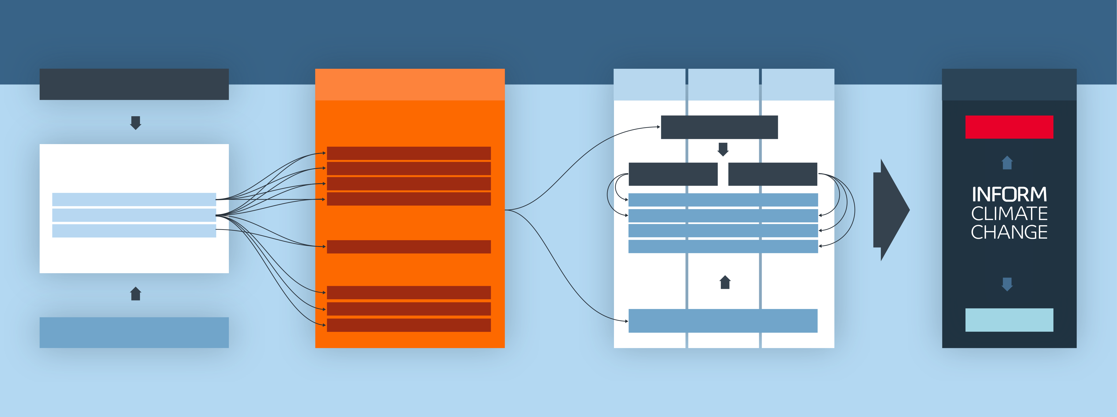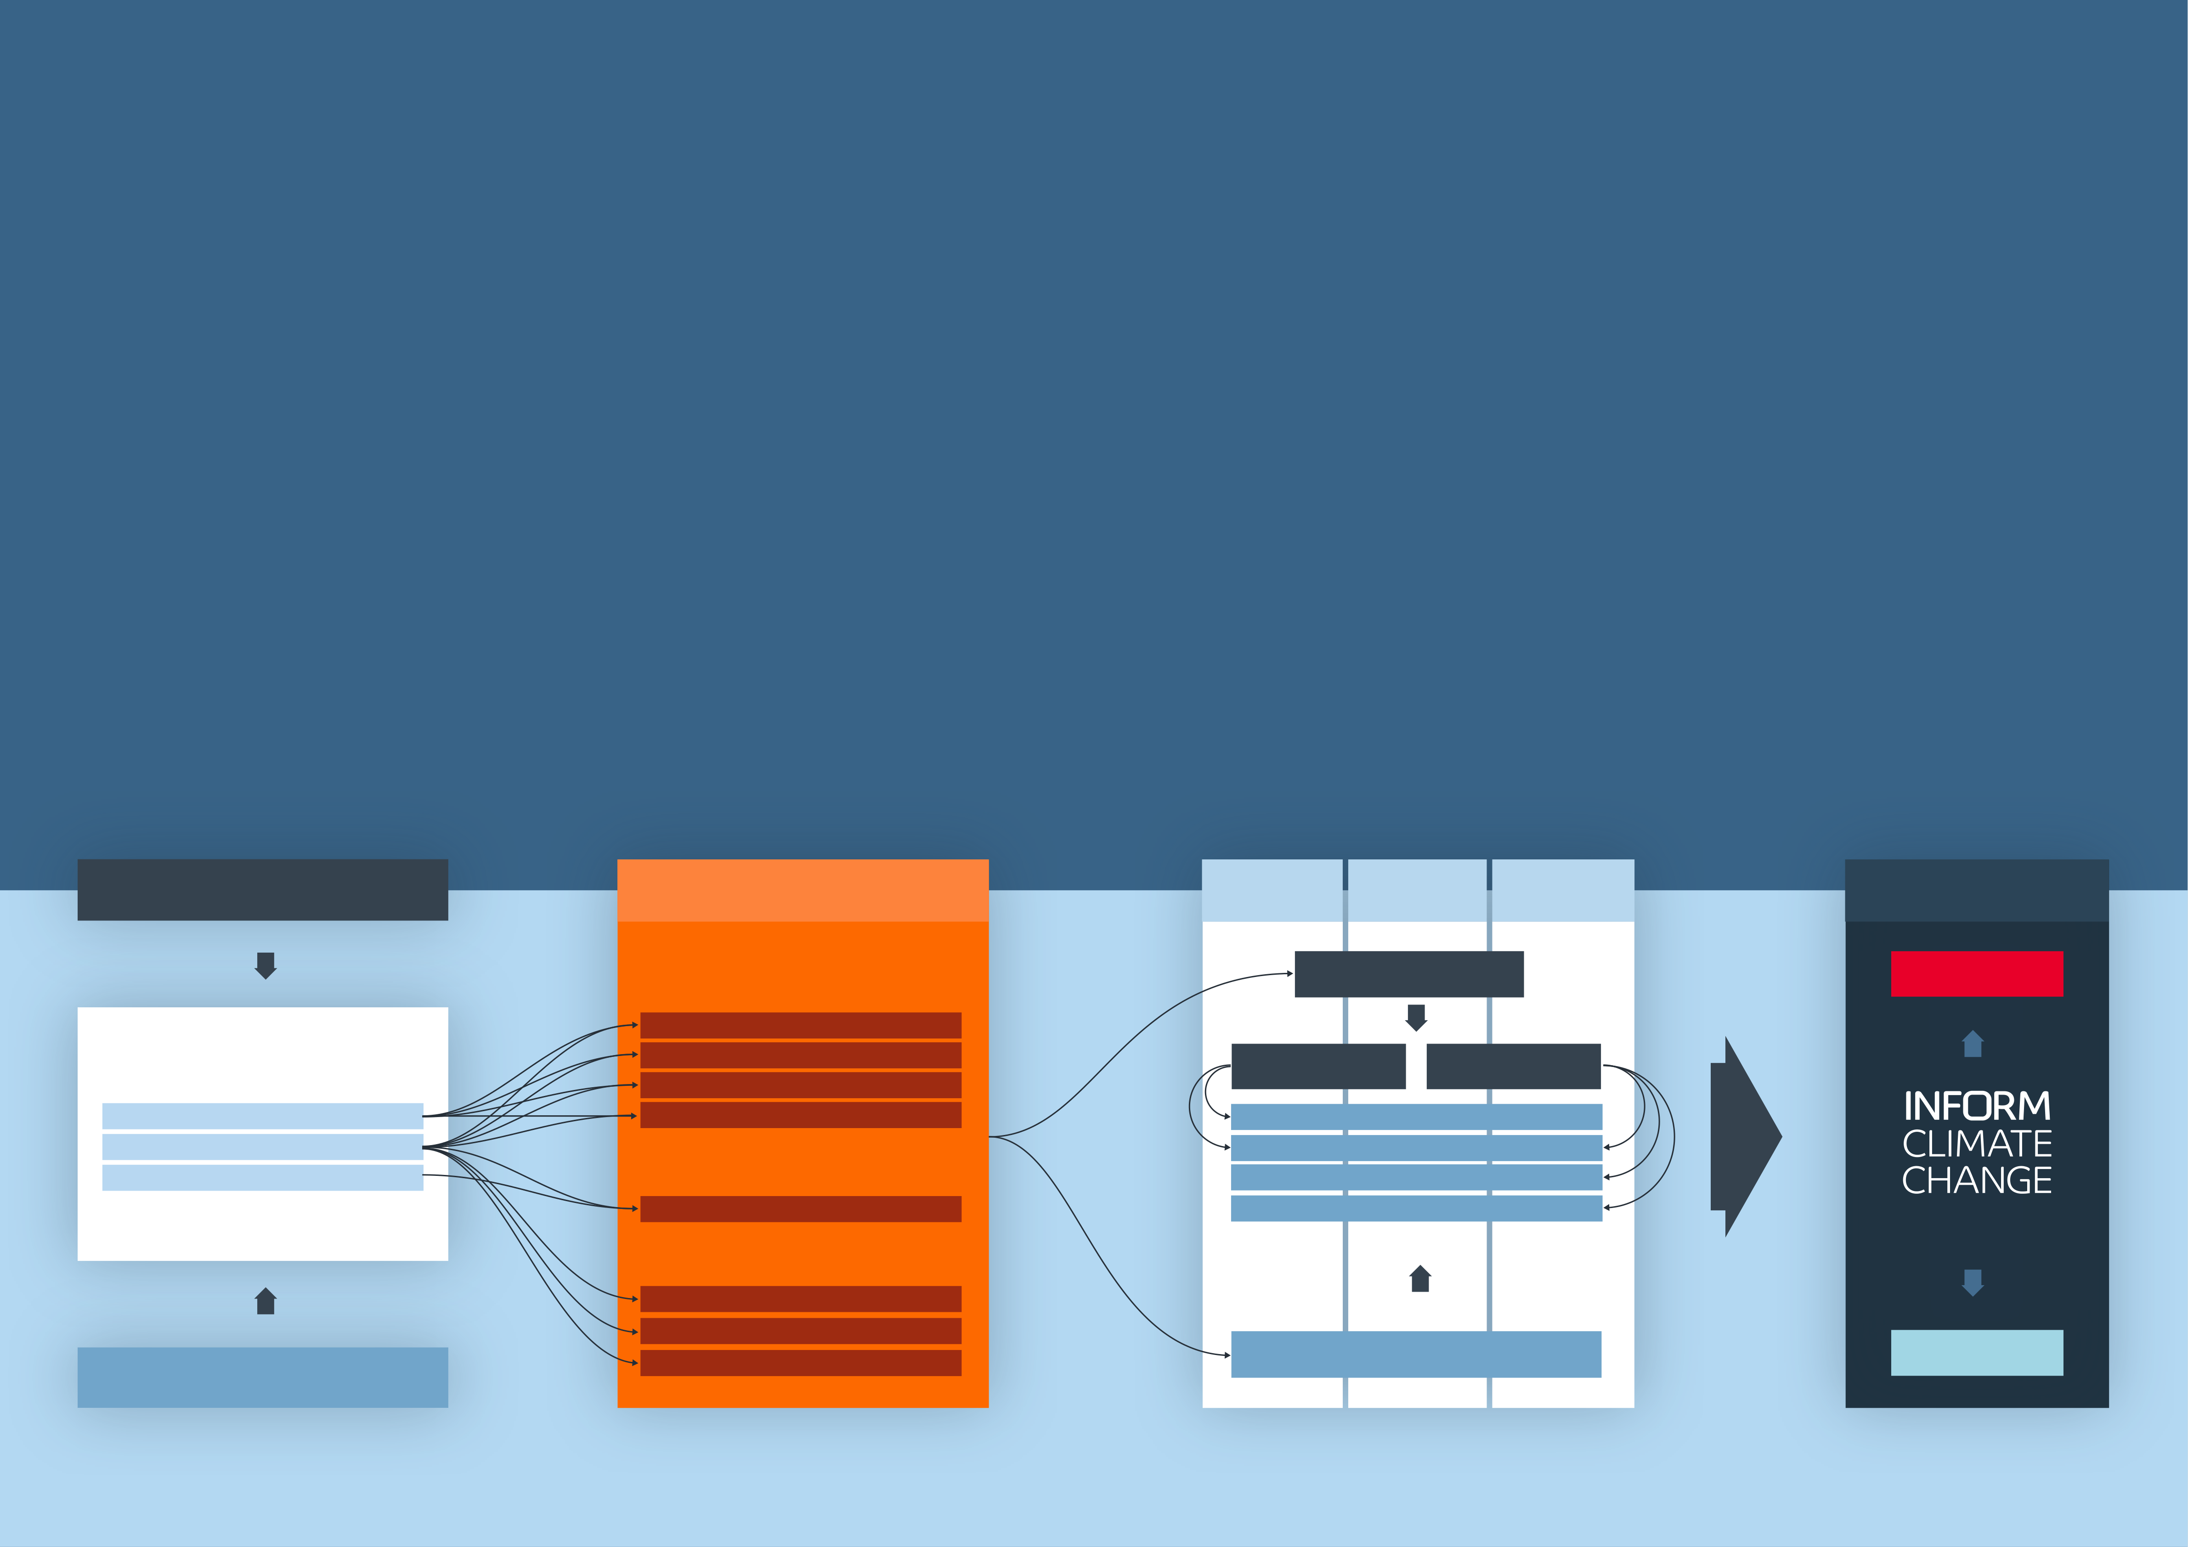

**INFORM CLIMATE CHANGE**

|  |  |  |  |
| --- | --- | --- | --- |
| INFORM Climate Change is a | **Objectives** | **How it works** | The population projections derived from SSPs are also |
| new INFORM product based on the | The objective of INFORM Climate Change is to inform | INFORM Climate Change incorporates climate and |
| INFORM Risk Index. It incorporates | decision-making around the risk of climate-amplified | socioeconomic projections into the methodology |
| applied to non-climate natural hazards (earthquake, |
| climate and socioeconomic projections | hazards, as well as how increased risks could be offset | of the INFORM Risk Index. Specifically, it uses a |
| tsunami) and non-modelled hazards (tropical |
| to analyse how risk will change as a | by improved vulnerability and coping capacity. | combination of: | cyclone wind). Tropical cyclone wind has not been |
| Specifically, it is intended to: | • Representative Concentration Pathways (RCPs) | included because changes cannot be modelled with |
| result of climate change under different |
| sufficient geographic accuracy. Population and other |
| emission and population scenarios. | • Lead to a shared and objective understanding | describing the evolution of future atmospheric |
| socioeconomic projections are used to project conflict |
| greenhouse gas concentrations and other |
| INFORM Climate Change is a result | of the impact of climate change on the risk of |
| radiative forcings | hazard. In future iterations of the tool, changes to |
| humanitarian crises |
| of collaboration between the Euro- |
| • Shared Socioeconomic Pathways (SSPs) that portray | vulnerability may also be included. |
| • Support policy-making that leads to greater resilience |
| Mediterranean Center on Climate |
| to the adverse impacts of climate change | how socioeconomic factors may change over the | The projections are applied at different timeframes |
| Change and Joint Research Centre |
| • Support decisions on the allocation of DRR and climate | next century | (2022, 2050, 2080) to calculate the Change in risk and |
| of European Commission. | Together, these scenarios are used to project the | the Vulnerability gap – the level of vulnerability reduction |
| adaptation resources that is consistent with SDG and |
| or coping capacity increase required for a country to |
| Sendai targets | Hazard and Exposure dimension of the INFORM Risk |
| • Identify inequalities in climate impacts, for example | preserve its current level of risk. |
| Index into the future, taking into account changes to |
| climate-related hazards (river flood, drought, coastal |
| on marginalised groups like people on the move |
| flood and epidemics) and the distribution of exposed |

populations. The epidemics component comprises

malaria and dengue.

|  |  |  |  |  |  |
| --- | --- | --- | --- | --- | --- |
| **Representative Concentration Pathways (RCPs)** | INFORM Risk Index Hazard | 2022 | 2050 | 2080 | Results |
| and Exposure dimension |

**Concentration Pathway**  **Change in risk**

**Climate hazards**

River Flood

|  |  |  |  |
| --- | --- | --- | --- |
| **Climate & Socioeconomic Projections** | Coastal Flood | Moderate (RCP4.5) | High (RCP8.5) |
| Drought |
| Epidemics (malaria and dengue) | Sustainability (SSP1) | |
| Hazard Projections |
| Demographic Projections | **Non-climate and non-modelled hazards** | Middle of the road (SSP2) | |
| Other Socioeconomic Projections | Regional rivalry (SSP3) | |
| Conflict | Fossil Fuel Development (SSP5) | |

SHARING CRISIS ANALYSIS

Tsunami

Cyclone

|  |  |  |  |
| --- | --- | --- | --- |
| **Shared Socioeconomic Pathways (SSPs)** | Earthquake | **Socioeconomic Pathway** | **Vulnerability gap** |

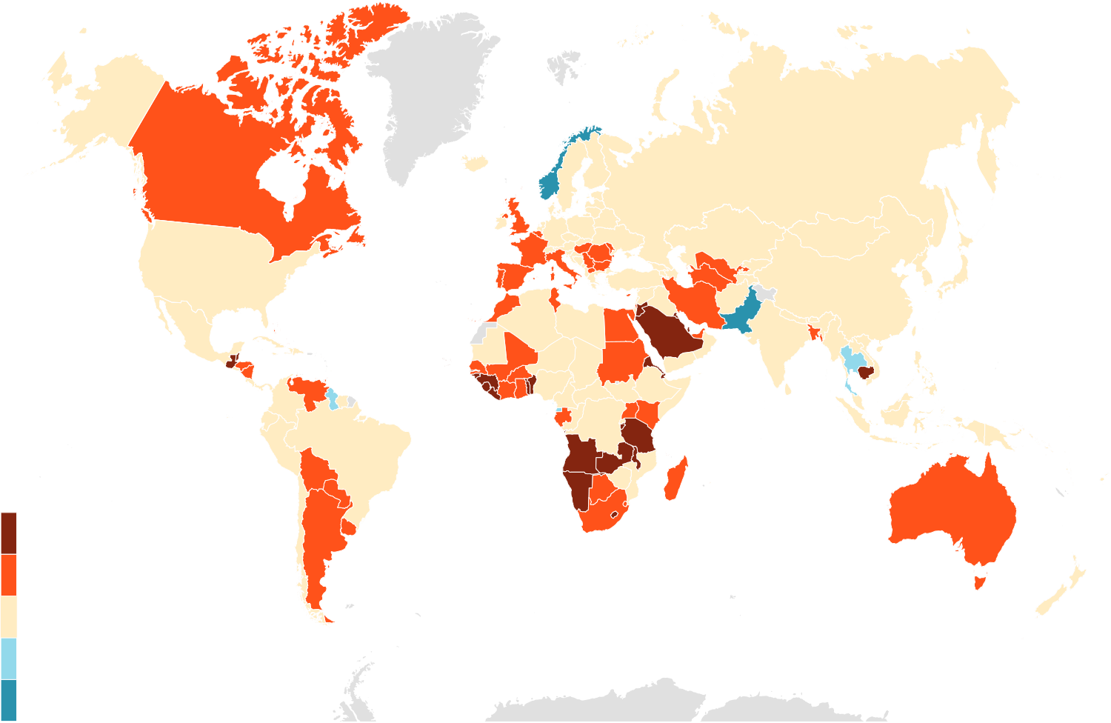

INFORM Climate Change Results

|  |  |  |
| --- | --- | --- |
| **Interpreting the results** | |  | | --- | | **Pessimistic** climate and socio-economic scenario (RCP 8.5 + SSP3) | |

|  |  |  |
| --- | --- | --- |
| INFORM Climate Change is based on the INFORM Risk | **Change in risk (2050-baseline)** | **Vulnerability gap** |
| Index methodology, so it measures changes in the risk of a |

humanitarian crisis that could overwhelm national capacity.

|  |  |  |
| --- | --- | --- |
| The results of INFORM Climate Change include the |  |  |
| following: |
| **• INFORM Climate Change Risk Index baseline** – |
| a slightly adapted INFORM Risk Index that allows |
| comparison with future hazard projections. |
| **• INFORM Climate Change Risk Index** – this shows |
| the future risk, taking into account climate and |
| socio-economic changes for different scenarios and |
| timeframes. |
| **• Change in risk** – this shows the change in the baseline |
| risk index taking into account climate, demographic and |
| socio-economic projections. |
| **• Vulnerability Gap** – this shows the change in 1 |
| Vulnerability and Lack of Coping Capacity (see INFORM |
| Risk Index analytical framework), which would be required |
| to maintain the baseline level of risk (i.e. to compensate |
| for increases in risk due to climate, demographic and |  |  |
| socio-economic factors). |

These maps and the following tables summarise the

|  |  |  |  |
| --- | --- | --- | --- |
| change in risk and vulnerability gap for mid-century (≈2050) | |  | | --- | | **Optimistic**climate and socio-economic scenario (RCP 4.5 + SSP1) | |  |
| under both pessimistic and optimistic climate and socio- |
|  | **Change in risk (2050-baseline)** | **Vulnerability gap** |
| economic scenarios. |

For a full explanation of the methodology, scenario

|  |  |  |  |
| --- | --- | --- | --- |
| selection, results and analysis, see the **[INFORM Climate](https://drmkc.jrc.ec.europa.eu/inform-index/Portals/0/InfoRM/2022/INFORM%20Climate%20Change%20Brochure.pdf)** | |  |  |
| **[Change Report](https://drmkc.jrc.ec.europa.eu/inform-index/Portals/0/InfoRM/2022/INFORM%20Climate%20Change%20Brochure.pdf)** and **[webpage](http://drmkc.jrc.ec.europa.eu/inform-index/INFORM-Climate-Change)**. | |
| **INFORM Climate Change scenario combinations** | |
| **Pessimistic**  RCP 8.5 + SSP 3 | |  | | --- | | **Optimistic Optimistic**  RCP 4.5 + SSP 1 RCP 4.5 + SSP 1 | |  |  |
| **SSP3 envisages** | |  | | --- | | **SSP1 envisages SSP1 envisages** | | **KEY** |  |
| • relatively low income growth• low human capital investments | |  | | --- | | • global population peak • global population peak  in mid-century in mid-century | |
| • high fertility and population growth rates in currently high fertility countries | |  | | --- | | • reasonably high pace in sustainable • reasonably high pace in sustainable  development development | |
| • low or negative population growth | |  | | --- | | • lessened inequalities• lessened inequalities | |
| in currently low fertility rate countries• low migration | |  | | --- | | • rapid technological growth based • rapid technological growth based  on low carbon energy sources on low carbon energy sources | |
| LARGE INCREASE |
| • slow urbanization. | |  | | --- | | • high productivity of land.• high productivity of land. | |
| INCREASE |
| STABLE |  |



|  |  |
| --- | --- |
| DECREASE  LARGE DECREASE |  |

The depiction and use of boundaries are not warranted to be error free nor do they necessarily

|  |  |  |
| --- | --- | --- |
| 16 | imply official endorsement or acceptance by the United Nations and European Union. | 17 |

|  |  |  |  |  |  |  |  |  |  |  |  |  |  |  |  |  |  |  |  |  |  |  |  |  |  |  |  |  |  |  |  |  |  |  |  |  |  |  |  |  |  |  |  |  |  |  |  |  |  |  |  |  |  |  |  |  |  |  |  |  |  |  |  |  |  |  |  |  |  |  |  |  |  |  |  |  |  |  |  |  |  |  |  |  |  |  |  |  |  |  |  |  |  |  |  |  |  |  |  |  |  |  |  |  |  |  |  |  |  |  |  |  |  |  |  |  |  |  |  |  |  |  |  |  |  |  |  |  |  |  |  |  |  |  |  |  |  |  |  |  |  |  |  |  |  |  |  |  |  |  |  |  |  |  |  |  |  |  |  |  |  |  |  |  |  |  |  |  |  |  |  |  |  |  |  |  |  |  |  |  |  |  |  |  |  |  |  |  |  |  |  |  |  |  |  |  |  |  |  |  |  |  |  |  |  |  |  |  |  |  |  |  |  |  |  |  |  |  |  |  |  |  |  |  |  |  |  |  |  |  |  |  |  |  |  |  |  |  |  |  |  |  |  |  |  |  |  |  |  |  |  |  |  |  |  |  |  |  |  |  |  |  |  |  |  |  |  |  |  |  |  |  |  |  |  |  |  |  |  |  |  |  |  |  |  |  |  |  |  |  |  |  |  |  |  |  |  |  |  |  |  |  |  |  |  |  |  |  |  |  |  |  |  |  |  |  |  |  |  |  |  |  |  |  |  |  |  |  |  |  |  |  |  |  |  |  |  |  |  |  |  |  |  |  |  |  |  |  |  |  |  |  |  |  |  |  |  |
| --- | --- | --- | --- | --- | --- | --- | --- | --- | --- | --- | --- | --- | --- | --- | --- | --- | --- | --- | --- | --- | --- | --- | --- | --- | --- | --- | --- | --- | --- | --- | --- | --- | --- | --- | --- | --- | --- | --- | --- | --- | --- | --- | --- | --- | --- | --- | --- | --- | --- | --- | --- | --- | --- | --- | --- | --- | --- | --- | --- | --- | --- | --- | --- | --- | --- | --- | --- | --- | --- | --- | --- | --- | --- | --- | --- | --- | --- | --- | --- | --- | --- | --- | --- | --- | --- | --- | --- | --- | --- | --- | --- | --- | --- | --- | --- | --- | --- | --- | --- | --- | --- | --- | --- | --- | --- | --- | --- | --- | --- | --- | --- | --- | --- | --- | --- | --- | --- | --- | --- | --- | --- | --- | --- | --- | --- | --- | --- | --- | --- | --- | --- | --- | --- | --- | --- | --- | --- | --- | --- | --- | --- | --- | --- | --- | --- | --- | --- | --- | --- | --- | --- | --- | --- | --- | --- | --- | --- | --- | --- | --- | --- | --- | --- | --- | --- | --- | --- | --- | --- | --- | --- | --- | --- | --- | --- | --- | --- | --- | --- | --- | --- | --- | --- | --- | --- | --- | --- | --- | --- | --- | --- | --- | --- | --- | --- | --- | --- | --- | --- | --- | --- | --- | --- | --- | --- | --- | --- | --- | --- | --- | --- | --- | --- | --- | --- | --- | --- | --- | --- | --- | --- | --- | --- | --- | --- | --- | --- | --- | --- | --- | --- | --- | --- | --- | --- | --- | --- | --- | --- | --- | --- | --- | --- | --- | --- | --- | --- | --- | --- | --- | --- | --- | --- | --- | --- | --- | --- | --- | --- | --- | --- | --- | --- | --- | --- | --- | --- | --- | --- | --- | --- | --- | --- | --- | --- | --- | --- | --- | --- | --- | --- | --- | --- | --- | --- | --- | --- | --- | --- | --- | --- | --- | --- | --- | --- | --- | --- | --- | --- | --- | --- | --- | --- | --- | --- | --- | --- | --- | --- | --- | --- | --- | --- | --- | --- | --- | --- | --- | --- | --- | --- | --- | --- | --- | --- | --- | --- | --- | --- | --- | --- | --- | --- | --- | --- | --- | --- | --- | --- | --- | --- | --- | --- | --- | --- | --- | --- | --- | --- | --- | --- | --- | --- | --- | --- | --- | --- |
| INFORM Climate Change Results | |  |  |  |  |  | | --- | --- | --- | --- | --- | | **COUNTRY** | Baseline (current) risk (B) | **MID-CENTURY (≈2050) CRISIS RISK** | | | | **PESSIMISTIC (P)**  climate and socio-economic scenario | | | | INFORM CC Risk  Index 2022 | INFORM CC  Risk Index | Change in risk | Vulnerability gap | | Brunei Darussalam | 1.9 | 2.0 | 0.1 | 0.1 | | Bulgaria | 2.2 | 2.5 | 0.3 | 0.2 | | Burkina Faso | 6.4 | 6.6 | 0.2 | 0.6 | | Burundi | 5.1 | 5.8 | 0.7 | 1 .8 | | Cabo Verde | 1.9 | 2.5 | 0.6 | 0.7 | | Cambodia | 4.6 | 5.2 | 0.6 | 1 .0 | | Cameroon | 6.2 | 6.4 | 0.2 | 0.4 | | Canada | 2.5 | 2.7 | 0.2 | 0.1 | | Central African Republic | 7 .7 | 7 .8 | 0.1 | 0.4 | | Chad | 7 .8 | 7 .9 | 0.1 | 0.3 | | Chile | 3.3 | 3.5 | 0.2 | 0.2 | | China | 3.9 | 4.0 | 0.1 | 0.1 | | Colombia | 5.4 | 5.5 | 0.1 | 0.1 | | Comoros | 3.8 | 4.4 | 0.6 | 1 .4 | | Congo | 5.2 | 5.3 | 0.1 | 0.4 | | Congo DR | 7 .6 | 7 .8 | 0.2 | 0.5 | | Costa Rica | 3.2 | 3.4 | 0.2 | 0.2 | | Côte d’Ivoire | 4.7 | 5.2 | 0.5 | 1 .1 | | Croatia | 2.2 | 2.3 | 0.1 | 0.1 | | Cuba | 2.4 | 2.4 | 0.0 | 0.0 | | Cyprus | 2.6 | 2.8 | 0.2 | 0.2 | | Czech Republic | 1.2 | 1.3 | 0.1 | 0.0 | | Denmark | 1.4 | 1.5 | 0.1 | 0.1 | | Djibouti | 4.4 | 4.9 | 0.5 | 1 .2 | | Dominica | 2.6 | 2.6 | 0.0 | 0.0 | | Dominican Republic | 4.2 | 4.4 | 0.2 | 0.3 | | Ecuador | 4.4 | 4.6 | 0.2 | 0.3 | | Egypt | 4.8 | 5.0 | 0.2 | 0.2 | | El Salvador | 4.3 | 4.6 | 0.3 | 0.5 | | Equatorial Guinea | 3.8 | 3.6 | -0.2 | -0.3 | | Eritrea | 4.0 | 4.9 | 0.9 | 1 .9 | | Estonia | 1.0 | 1.0 | 0.0 | 0.0 | | Eswatini | 3.3 | 3.5 | 0.2 | 0.5 | | | |  |  |  |  |  | | --- | --- | --- | --- | --- | | **COUNTRY** | Baseline (current) risk (B) | **MID-CENTURY (≈2050) CRISIS RISK** | | | | **PESSIMISTIC (P)**  climate and socio-economic scenario | | | | INFORM CC Risk  Index 2022 | INFORM CC  Risk Index | Change in risk | Vulnerability gap | | Ethiopia | 6.8 | 6.9 | 0.1 | 0.2 | | Fiji | 3.2 | 3.1 | -0.1 | -0.1 | | Finland | 1.3 | 1.4 | 0.1 | 0.1 | | France | 2.4 | 2.6 | 0.2 | 0.1 | | Gabon | 3.7 | 4.1 | 0.4 | 0.7 | | Gambia | 3.6 | 4.4 | 0.8 | 1.4 | | Georgia | 3.1 | 3.2 | 0.1 | 0.2 | | Germany | 2.4 | 2.5 | 0.1 | 0.1 | | Ghana | 4.0 | 4.4 | 0.4 | 0.6 | | Greece | 2.7 | 2.8 | 0.1 | 0.1 | | Grenada | 1.7 | 1.7 | 0.0 | 0.0 | | Guatemala | 5.1 | 5.8 | 0.7 | 1.2 | | Guinea | 4.4 | 5.0 | 0.6 | 1.2 | | Guinea-Bissau | 4.1 | 5.0 | 0.9 | 2.4 | | Guyana | 4.3 | 4.2 | -0.1 | -0.2 | | Haiti | 5.5 | 5.8 | 0.3 | 0.7 | | Honduras | 4.9 | 5.4 | 0.5 | 0.9 | | Hungary | 1.5 | 1.8 | 0.3 | 0.1 | | Iceland | 1.3 | 1.3 | 0.0 | 0.0 | | India | 5.5 | 5.5 | 0.0 | 0.1 | | Indonesia | 4.4 | 4.7 | 0.3 | 0.2 | | Iran | 4.3 | 4.8 | 0.5 | 0.7 | | Iraq | 6.6 | 6.6 | 0.0 | 0.2 | | Ireland | 1.7 | 1.7 | 0.0 | 0.0 | | Israel | 2.6 | 2.7 | 0.1 | 0.1 | | Italy | 2.5 | 2.7 | 0.2 | 0.1 | | Jamaica | 3.0 | 3.2 | 0.2 | 0.2 | | Japan | 2.3 | 2.3 | 0.0 | 0.0 | | Jordan | 3.5 | 4.1 | 0.6 | 1.2 | | Kazakhstan | 1.6 | 1.8 | 0.2 | 0.1 | | Kenya | 4.6 | 5.1 | 0.5 | 1.0 | | Kiribati | 3.0 | 3.7 | 0.7 | 1.5 | | Korea DPR | 4.6 | 4.7 | 0.1 | 0.3 | |
| This table shows top level results from INFORM Climate Change: the current |
| INFORM Climate Change Risk Index, and – for mid-century (≈2050) under |
| the pessimistic climate and socio-economic scenario – the INFORM Climate |
| Change Risk Index, the change in risk and the vulnerability gap. |
| |  |  |  |  |  | | --- | --- | --- | --- | --- | | **COUNTRY** | Baseline (current) risk (B) | **MID-CENTURY (≈2050) CRISIS RISK** | | | | **PESSIMISTIC (P)**  climate and socio-economic scenario | | | | INFORM CC Risk  Index 2022 | INFORM CC  Risk Index | Change in risk | Vulnerability gap | | Afghanistan | 8.0 | 8.1 | 0.1 | 0.2 | | Albania | 2.6 | 2.7 | 0.1 | 0.1 | | Algeria | 3.9 | 4.1 | 0.2 | 0.2 | | Angola | 4.5 | 5.4 | 0.9 | 1 .8 | | Antigua and Barbuda | 2.0 | 2.2 | 0.2 | 0.2 | | Argentina | 2.9 | 3.2 | 0.3 | 0.2 | | Armenia | 5.3 | 5.4 | 0.1 | 0.1 | | Australia | 2.4 | 2.6 | 0.2 | 0.1 | | Austria | 1.9 | 2.0 | 0.1 | 0.1 | | Azerbaijan | 5.8 | 5.9 | 0.1 | 0.1 | | Bahamas | 1.9 | 2.2 | 0.3 | 0.2 | | Bahrain | 1.1 | 1.4 | 0.3 | 0.2 | | Bangladesh | 5.5 | 5.9 | 0.4 | 0.5 | | Barbados | 1.8 | 1.8 | 0.0 | -0.0 | | Belarus | 1.4 | 1.6 | 0.2 | 0.1 | | Belgium | 1.9 | 2.0 | 0.1 | 0.1 | | Belize | 3.3 | 3.7 | 0.4 | 0.6 | | Benin | 4.1 | 4.9 | 0.8 | 1 .8 | | Bhutan | 3.2 | 3.3 | 0.1 | 0.3 | | Bolivia | 3.5 | 3.9 | 0.4 | 0.7 | | Bosnia and Herzegovina | 3.1 | 3.3 | 0.2 | 0.3 | | Botswana | 2.9 | 3.3 | 0.4 | 0.6 | | Brazil | 5.0 | 5.1 | 0.1 | 0.0 | |
| |  |  |  |  |  |  |  | | --- | --- | --- | --- | --- | --- | --- | | **KEY** | CLIMATE CHANGE RISK INDEX | **VERY HIGH** | **HIGH** | **MEDIUM** | **LOW** | **VERY LOW** | | | |  |  |  |  |  |  | | --- | --- | --- | --- | --- | --- | | CHANGE IN RISK / VULNERABILTY GAP | **LARGE INCREASE** | **INCREASE** | **STABLE** | **DECREASE** | **LARGE DECREASE** | | |
| 18 | 19 | | |

|  |  |  |  |  |  |  |  |  |  |  |  |  |  |  |  |  |  |  |  |  |  |  |  |  |  |  |  |  |  |  |  |  |  |  |  |  |  |  |  |  |  |  |  |  |  |  |  |  |  |  |  |  |  |  |  |  |  |  |  |  |  |  |  |  |  |  |  |  |  |  |  |  |  |  |  |  |  |  |  |  |  |  |  |  |  |  |  |  |  |  |  |  |  |  |  |  |  |  |  |  |  |  |  |  |  |  |  |  |  |  |  |  |  |  |  |  |  |  |  |  |  |  |  |  |  |  |  |  |  |  |  |  |  |  |  |  |  |  |  |  |  |  |  |  |  |  |  |  |  |  |  |  |  |  |  |  |  |  |  |  |  |  |  |  |  |  |  |  |  |  |  |  |  |  |  |  |  |  |  |  |  |  |  |  |  |  |  |  |  |  |  |  |  |  |  |  |  |  |  |  |  |  |  |  |  |  |  |  |  |  |  |  |  |  |  |  |  |  |  |  |  |  |  |  |  |  |  |  |  |  |  |  |  |  |  |  |  |  |  |  |  |  |  |  |  |  |  |  |  |  |  |  |  |  |  |  |  |  |  |  |  |  |  |  |  |  |  |  |  |  |  |  |  |  |  |  |  |  |  |  |  |  |  |  |  |  |  |  |  |  |  |  |  |  |  |  |  |  |  |  |  |  |  |  |  |  |  |  |  |  |  |  |  |  |  |  |  |  |  |  |  |  |  |  |  |  |  |  |  |  |  |  |  |  |  |  |  |  |  |  |  |  |  |  |  |  |  |  |  |  |  |  |  |  |  |  |  |  |  |  |  |  |  |  |  |  |  |  |  |  |  |  |  |  |  |  |  |  |  |  |  |  |  |  |  |  |  |  |  |  |  |  |  |  |  |  |  |  |  |  |  |  |  |  |  |  |  |  |  |  |  |  |  |  |  |  |  |  |  |  |  |  |  |  |  |  |  |  |  |  |  |  |  |  |  |  |  |  |  |  |  |  |  |  |  |  |  |  |  |  |  |  |  |  |  |  |  |  |  |  |  |  |  |  |  |  |  |  |  |  |  |  |  |  |  |  |  |  |  |  |  |  |  |  |  |  |  |  |  |  |  |  |  |  |  |  |  |  |  |  |  |  |  |  |  |  |  |  |  |  |  |  |  |  |  |  |  |  |  |  |  |  |  |  |  |  |  |  |  |  |  |  |  |  |  |  |  |  |  |  |  |  |  |  |  |  |  |  |  |
| --- | --- | --- | --- | --- | --- | --- | --- | --- | --- | --- | --- | --- | --- | --- | --- | --- | --- | --- | --- | --- | --- | --- | --- | --- | --- | --- | --- | --- | --- | --- | --- | --- | --- | --- | --- | --- | --- | --- | --- | --- | --- | --- | --- | --- | --- | --- | --- | --- | --- | --- | --- | --- | --- | --- | --- | --- | --- | --- | --- | --- | --- | --- | --- | --- | --- | --- | --- | --- | --- | --- | --- | --- | --- | --- | --- | --- | --- | --- | --- | --- | --- | --- | --- | --- | --- | --- | --- | --- | --- | --- | --- | --- | --- | --- | --- | --- | --- | --- | --- | --- | --- | --- | --- | --- | --- | --- | --- | --- | --- | --- | --- | --- | --- | --- | --- | --- | --- | --- | --- | --- | --- | --- | --- | --- | --- | --- | --- | --- | --- | --- | --- | --- | --- | --- | --- | --- | --- | --- | --- | --- | --- | --- | --- | --- | --- | --- | --- | --- | --- | --- | --- | --- | --- | --- | --- | --- | --- | --- | --- | --- | --- | --- | --- | --- | --- | --- | --- | --- | --- | --- | --- | --- | --- | --- | --- | --- | --- | --- | --- | --- | --- | --- | --- | --- | --- | --- | --- | --- | --- | --- | --- | --- | --- | --- | --- | --- | --- | --- | --- | --- | --- | --- | --- | --- | --- | --- | --- | --- | --- | --- | --- | --- | --- | --- | --- | --- | --- | --- | --- | --- | --- | --- | --- | --- | --- | --- | --- | --- | --- | --- | --- | --- | --- | --- | --- | --- | --- | --- | --- | --- | --- | --- | --- | --- | --- | --- | --- | --- | --- | --- | --- | --- | --- | --- | --- | --- | --- | --- | --- | --- | --- | --- | --- | --- | --- | --- | --- | --- | --- | --- | --- | --- | --- | --- | --- | --- | --- | --- | --- | --- | --- | --- | --- | --- | --- | --- | --- | --- | --- | --- | --- | --- | --- | --- | --- | --- | --- | --- | --- | --- | --- | --- | --- | --- | --- | --- | --- | --- | --- | --- | --- | --- | --- | --- | --- | --- | --- | --- | --- | --- | --- | --- | --- | --- | --- | --- | --- | --- | --- | --- | --- | --- | --- | --- | --- | --- | --- | --- | --- | --- | --- | --- | --- | --- | --- | --- | --- | --- | --- | --- | --- | --- | --- | --- | --- | --- | --- | --- | --- | --- | --- | --- | --- | --- | --- | --- | --- | --- | --- | --- | --- | --- | --- | --- | --- | --- | --- | --- | --- | --- | --- | --- | --- | --- | --- | --- | --- | --- | --- | --- | --- | --- | --- | --- | --- | --- | --- | --- | --- | --- | --- | --- | --- | --- | --- | --- | --- | --- | --- | --- | --- | --- | --- | --- | --- | --- | --- | --- | --- | --- | --- | --- | --- | --- | --- | --- | --- | --- | --- | --- | --- | --- | --- | --- | --- | --- | --- | --- | --- | --- | --- | --- | --- | --- | --- | --- | --- | --- | --- | --- | --- | --- | --- | --- | --- | --- | --- | --- | --- | --- | --- | --- | --- | --- | --- | --- | --- | --- | --- | --- | --- | --- | --- | --- | --- | --- | --- | --- | --- | --- | --- | --- | --- | --- | --- | --- | --- | --- | --- | --- | --- | --- | --- | --- | --- | --- | --- | --- | --- | --- | --- | --- | --- | --- | --- | --- | --- | --- | --- | --- | --- | --- | --- | --- | --- | --- | --- | --- | --- | --- | --- | --- | --- | --- | --- | --- | --- | --- | --- | --- | --- | --- | --- | --- | --- | --- | --- | --- | --- | --- | --- | --- | --- | --- | --- | --- | --- | --- | --- |
| |  |  |  |  |  | | --- | --- | --- | --- | --- | | **COUNTRY** | Baseline (current) risk (B) | **MID-CENTURY (≈2050) CRISIS RISK** | | | | **PESSIMISTIC (P)**  climate and socio-economic scenario | | | | INFORM CC Risk  Index 2022 | INFORM CC  Risk Index | Change in risk | Vulnerability gap | | Korea Republic of | 2.1 | 2.1 | 0.0 | 0.0 | | Kuwait | 1.7 | 2.2 | 0.5 | 0.4 | | Kyrgyzstan | 2.7 | 2.8 | 0.1 | 0.1 | | Lao PDR | 4.0 | 4.0 | 0.0 | -0.1 | | Latvia | 1.3 | 1.4 | 0.1 | 0.1 | | Lebanon | 3.9 | 4.2 | 0.3 | 0.5 | | Lesotho | 3.0 | 3.7 | 0.7 | 2.1 | | Liberia | 5.3 | 6.0 | 0.7 | 1 .8 | | Libya | 6.2 | 6.3 | 0.1 | 0.1 | | Liechtenstein | 1.1 | 1.1 | 0.0 | 0.0 | | Lithuania | 1.4 | 1.5 | 0.1 | 0.0 | | Luxembourg | 1.1 | 1.2 | 0.1 | 0.1 | | Madagascar | 5.2 | 5.7 | 0.5 | 1 .0 | | Malawi | 4.5 | 5.1 | 0.6 | 1 .4 | | Malaysia | 3.4 | 3.5 | 0.1 | 0.1 | | Maldives | 2.1 | 2.2 | 0.1 | 0.2 | | Mali | 6.9 | 7 .1 | 0.2 | 0.3 | | Malta | 1.5 | 1.5 | 0.0 | 0.0 | | Marshall Islands | 3.1 | 3.5 | 0.4 | 0.9 | | Mauritania | 4.6 | 5.0 | 0.4 | 1 .2 | | Mauritius | 2.1 | 2.2 | 0.1 | 0.0 | | Mexico | 5.0 | 5.0 | 0.0 | 0.1 | | Micronesia | 2.9 | 3.0 | 0.1 | 0.2 | | Moldova Republic of | 2.3 | 2.6 | 0.3 | 0.3 | | Mongolia | 2.4 | 2.6 | 0.2 | 0.2 | | Montenegro | 2.2 | 2.2 | 0.0 | 0.0 | | Morocco | 3.5 | 4.1 | 0.6 | 0.6 | | Mozambique | 7 .2 | 7 .3 | 0.1 | 0.2 | | Myanmar | 6.2 | 6.3 | 0.1 | 0.2 | | Namibia | 3.2 | 3.7 | 0.5 | 1 .0 | | Nauru | 2.4 | 2.4 | 0.0 | 0.0 | | Nepal | 4.5 | 5.0 | 0.5 | 0.8 | | Netherlands | 2.0 | 2.0 | 0.0 | 0.0 | | New Zealand | 1.6 | 1.7 | 0.1 | 0.0 | | |  |  |  |  |  | | --- | --- | --- | --- | --- | | **COUNTRY** | Baseline (current) risk (B) | **MID-CENTURY (≈2050) CRISIS RISK** | | | | **PESSIMISTIC (P)**  climate and socio-economic scenario | | | | INFORM CC Risk  Index 2022 | INFORM CC  Risk Index | Change in risk | Vulnerability gap | | Nicaragua | 4.3 | 4.7 | 0.4 | 0.6 | | Niger | 7.3 | 7.5 | 0.2 | 0.3 | | Nigeria | 6.6 | 6.7 | 0.1 | 0.2 | | North Macedonia | 2.1 | 2.3 | 0.2 | 0.2 | | Norway | 1.9 | 1.7 | -0.2 | -0.2 | | Oman | 2.4 | 2.6 | 0.2 | 0.2 | | Pakistan | 6.0 | 5.9 | -0.1 | -0.1 | | Palau | 2.5 | 2.6 | 0.1 | 0.2 | | Palestine | 3.4 | 3.8 | 0.4 | 0.9 | | Panama | 3.8 | 3.9 | 0.1 | 0.2 | | Papua New Guinea | 5.5 | 5.8 | 0.3 | 0.7 | | Paraguay | 2.7 | 3.1 | 0.4 | 0.5 | | Peru | 4.5 | 4.8 | 0.3 | 0.5 | | Philippines | 5.3 | 5.4 | 0.1 | 0.1 | | Poland | 1.7 | 1.9 | 0.2 | 0.1 | | Portugal | 1.7 | 1.9 | 0.2 | 0.1 | | Qatar | 1.2 | 1.9 | 0.7 | 0.3 | | Romania | 2.1 | 2.4 | 0.3 | 0.2 | | Russian Federation | 3.3 | 3.3 | 0.0 | -0.0 | | Rwanda | 4.7 | 5.4 | 0.7 | 1 .1 | | Saint Kitts and Nevis | 1.9 | 1.9 | 0.0 | 0.0 | | Saint Lucia | 1.9 | 1.9 | 0.0 | 0.0 | | Saint Vincent and the Grenadines | 2.4 | 2.4 | 0.0 | -0.1 | | Samoa | 3.0 | 3.0 | 0.0 | 0.0 | | Sao Tome and Principe | 1.9 | 2.4 | 0.5 | 1 .4 | | Saudi Arabia | 2.1 | 2.6 | 0.5 | 0.3 | | Senegal | 4.5 | 5.2 | 0.7 | 1 .2 | | Serbia | 2.4 | 2.7 | 0.3 | 0.2 | | Seychelles | 1.8 | 1.7 | -0.1 | -0.1 | | Sierra Leone | 4.7 | 5.3 | 0.6 | 1 .3 | | Singapore | 0.6 | 0.7 | 0.1 | 0.0 | | Slovakia | 1.5 | 1.7 | 0.2 | 0.1 | | Slovenia | 1.3 | 1.3 | 0.0 | 0.0 | | Solomon Islands | 4.1 | 4.3 | 0.2 | 0.4 | | | |  |  |  |  |  | | --- | --- | --- | --- | --- | | **COUNTRY** | Baseline (current) risk (B) | **MID-CENTURY (≈2050) CRISIS RISK** | | | | **PESSIMISTIC (P)**  climate and socio-economic scenario | | | | INFORM CC Risk  Index 2022 | INFORM CC  Risk Index | Change in risk | Vulnerability gap | | Somalia | 8.8 | 8.8 | 0.0 | 0.2 | | South Africa | 3.7 | 4.3 | 0.6 | 0.8 | | South Sudan | 8.5 | 8.6 | 0.1 | 0.3 | | Spain | 2.2 | 2.5 | 0.3 | 0.1 | | Sri Lanka | 3.4 | 3.6 | 0.2 | 0.2 | | Sudan | 6.4 | 6.6 | 0.2 | 0.4 | | Suriname | 3.5 | 3.7 | 0.2 | 0.2 | | Sweden | 1.8 | 1.9 | 0.1 | 0.1 | | Switzerland | 1.5 | 1.5 | 0.0 | 0.0 | | Syria | 7 .0 | 7 .0 | 0.0 | 0.1 | | Tajikistan | 3.4 | 3.6 | 0.2 | 0.3 | | Tanzania | 4.9 | 5.6 | 0.7 | 1.5 | | Thailand | 4.1 | 4.1 | 0.0 | 0.0 | | Timor-Leste | 4.5 | 4.6 | 0.1 | 0.3 | | Togo | 4.1 | 4.8 | 0.7 | 1.6 | | Tonga | 3.2 | 3.2 | 0.0 | 0.0 | | Trinidad and Tobago | 2.6 | 2.9 | 0.3 | 0.3 | | Tunisia | 3.0 | 3.3 | 0.3 | 0.3 | | Türkiye | 4.9 | 4.9 | 0.0 | 0.0 | | Turkmenistan | 2.0 | 2.3 | 0.3 | 0.3 | | Tuvalu | 2.7 | 2.7 | 0.0 | 0.0 | | Uganda | 6.2 | 6.6 | 0.4 | 0.9 | | Ukraine | 4.5 | 4.6 | 0.1 | 0.1 | | United Arab Emirates | 1.6 | 1.8 | 0.2 | 0.1 | | United Kingdom | 2.0 | 2.4 | 0.4 | 0.1 | | United States of America | 3.1 | 3.2 | 0.1 | 0.1 | | Uruguay | 2.1 | 2.3 | 0.2 | 0.2 | | Uzbekistan | 2.5 | 2.9 | 0.4 | 0.3 | | Vanuatu | 4.0 | 4.1 | 0.1 | 0.4 | | Venezuela | 4.2 | 4.6 | 0.4 | 0.5 | | Viet Nam | 3.7 | 3.8 | 0.1 | 0.1 | | Yemen | 8.1 | 8.2 | 0.1 | 0.3 | | Zambia | 4.2 | 5.0 | 0.8 | 1.7 | | Zimbabwe | 4.4 | 4.6 | 0.2 | 0.5 | |
| |  |  |  |  |  |  |  | | --- | --- | --- | --- | --- | --- | --- | | **KEY** | CLIMATE CHANGE RISK INDEX | **VERY HIGH** | **HIGH** | **MEDIUM** | **LOW** | **VERY LOW** | | | |  |  |  |  |  |  | | --- | --- | --- | --- | --- | --- | | CHANGE IN RISK / VULNERABILTY GAP | **LARGE INCREASE** | **INCREASE** | **STABLE** | **DECREASE** | **LARGE DECREASE** | | |
| 20 | 21 | | |

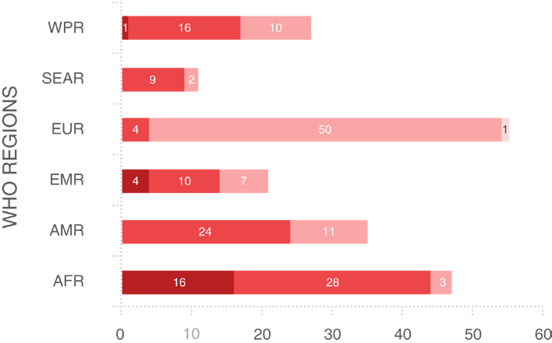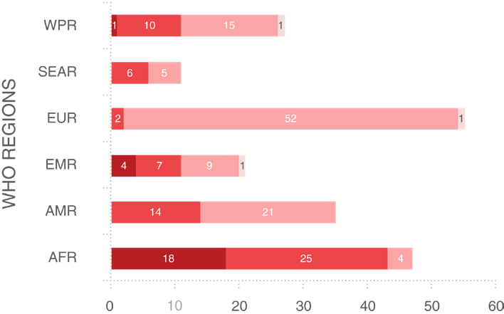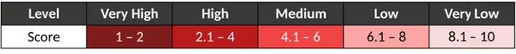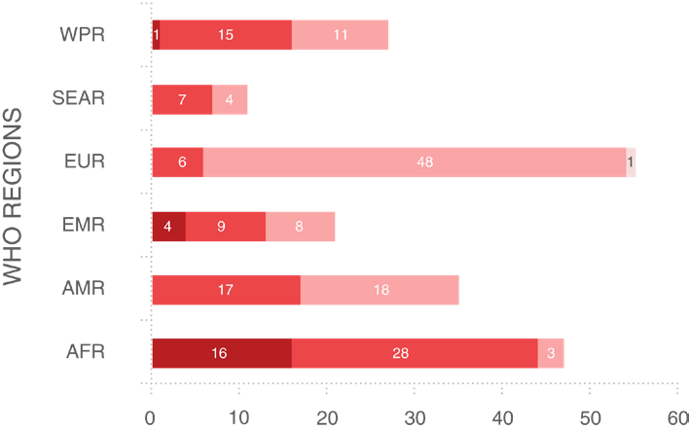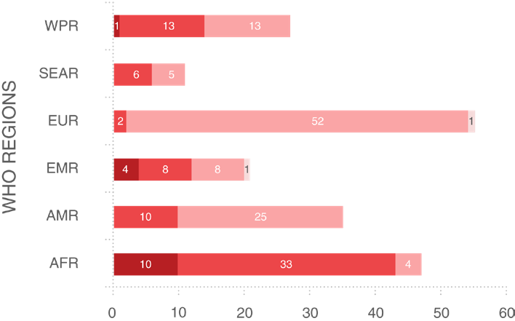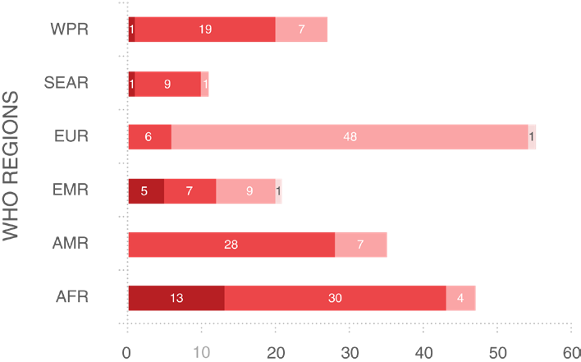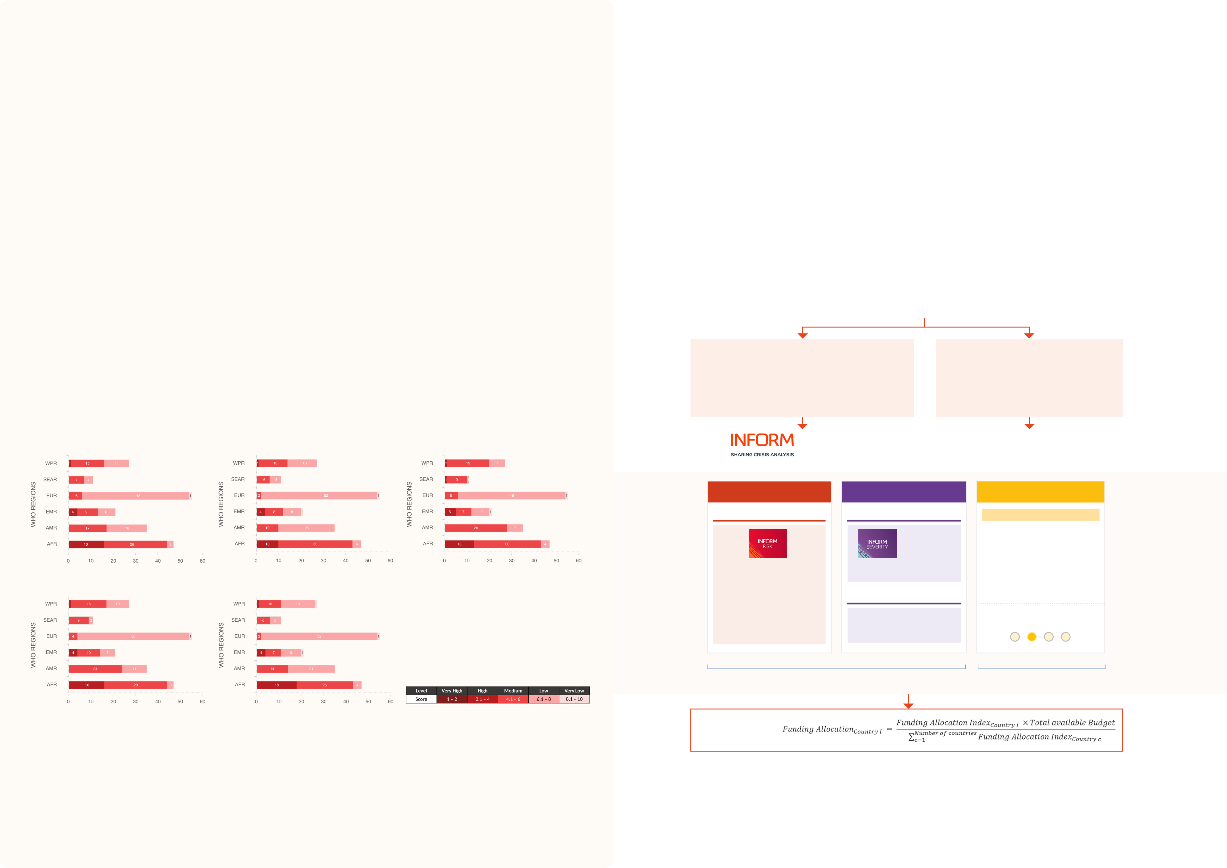

User example –   
WHO Dynamic Preparedness Metric

User example –   
European Commission Humanitarian Aid Funding Allocation

|  |  |  |  |
| --- | --- | --- | --- |
| **A dynamic, evidence-based, risk-based** | **Interpreting DPM results** | The European Commission Directorate-General for | • Based on scientific rigour and validated by large |
| **preparedness metric** | European Civil Protection and Humanitarian Aid Operations | community |
| Risks in the DPM are determined by aggregating indicators |
| (DG ECHO) uses INFORM's products in its evidence-based funding allocation methodology. DG ECHO states the  following as reasons for using INFORM's products: | • Offer a common approach to the humanitarian aid community for analysis of risks and crises to allow comparability and prioritisation |
| The World Health Organization (WHO) Dynamic | across 3 main conceptual risk dimensions (hazard, |
| Preparedness Metric (DPM) is a composite measure | vulnerability and capacity), using multisector open-source |
| of health emergency risks for 196 countries. It aims to | data to perform up-to-date contextual assessments. |
| Results are scored between 1.0 and 10.0. Low scores | • Fulfil ECHO’s requirements | • Offer a common and objective language to humanitarian |
| inform countries of their preparedness status and support |
| prioritization and implementation of specific actions to |
| represent poor performance (high risk) and high scores | • Transparent and freely accessible tools | actors |
| improve their capacities. The DPM is based on the INFORM |
| represent good performance (low risk). The notion that | • Global coverage | • Help to respect the humanitarian principles |
| Epidemic Risk Index. |
| higher is better is consistently applied across all DPM |
| The dynamism of the DPM is achieved through frequently | • Cover multiple types of hazards | • Constitute a powerful tool to align response planning by |
| scores. |
| different humanitarian actors | |
| updated indicators (such as epidemic outcomes, seasonal | **Example analysis of country prioritisation** |
| hazards, humanitarian crisis severity) and by presenting | DG ECHO’s evidence-based funding allocation methodology relies on | |
| risks for 5 different acute syndromes (respiratory, diarrhoeal, | The results of DPM can be used for global or regional |
| haemorrhagic, neurological and acute febrile illness). The | prioritization based on country syndromic risk or any of | Quantitative information | Expert information |
| DPM is updated quarterly using the latest available data. | its components. Countries are exposed to risk differently |
| depending on the type and nature of the communicable |
| disease, current vulnerabilities and existing capacities. Here |
| Requirements: | DG ECHO has field experts in more than 50 |
| we use the DPM to measure variation in risk across different |
| • Large number of countries covered (allowing comparison)• Solid scientific basis | countries, following the humanitarian situation in more than 110 countries |
| syndromes for countries within WHO regions. |
| • Neutral & independent | |
| • Validated by large community | |

**Analysis of the number of countries in each WHO region in each risk class of the DPM for 5 different acute syndromes**

|  |  |  |  |  |  |  |  |  |  |  |  |
| --- | --- | --- | --- | --- | --- | --- | --- | --- | --- | --- | --- |
| Respiratory DPM Index | Diarrhoeal DPM Index | | Haemorrhagic DPM Index | & People in Need | | | | Expert input | | | 23 |
| Questionnaire with rated answers completed with | | | | | | |
| expert analysis | | | | | | |
| **Risk** | | | **Severity** | **Expert Information** | | |
| INFORM Risk | | | INFORM Severity | Expert Survey | | |
| A | | | | | **Expert Index calculated for algorithm - Containing 11 questions** to assess | |
| humanitarian aid reponse, | | | | | | |
| Assesses **countries at risk** | | | Assesses the **severity of a crisis** | implementation capacity & | | |
| Neurological DPM Index | Acute Febrile Illness Index | | | of crisis & disaster that would | | | (Methodology: min. 2 years duration). | expected outlook of the crisis. | | |
| overwhelm national response | | | People in Need (PIN) | B | **Quality control** - 11 questions | |
| capacity. | | |
| to support decision makng. | |
| **Further information** | | | | Three dimensions: | | | **PIN levels 3-5**, representing the | Respondents choose from scale | |
| • • | hazard & exposure vulnerability; and | |
| (e.g. deteriorating - increasing) | |
| **moderate, severe and extreme** |
| **-** | **+** |
| • | lack of coping capacity. | | humanitarian conditions. |
| **10%** | | | **90%** | | | |
| **80%** Quantitative information | | | | **20%** Expert information | | |
| **Funding Allocation**  **Index** | | = | | | | |
| The password protected DPM Dashboard provides the access point to all DPM results, including country, regional and global profiles. Further information: [https://extranet.who.](https://extranet.who.int/sph/dpm)  [int/sph/dpm](https://extranet.who.int/sph/dpm). To gain access, please contact [ehs@who.int](mailto:ehs%40who.int?subject=) | | Kandel N, Chungong S. Dynamic preparedness metric: a paradigm shift to measure and act on preparedness. The Lancet Global Health 2022, 10(5):E615-616, doi:10.1016/ S2214-109X(22)00097-3 | | **Further information** | | | | | | |
| specifying the motivation for your request​ | | | | https://civil-protection-humanitarian-aid.ec.europa.eu/what/humanitarian-aid_en | | | | | | |
| 22 | | | |

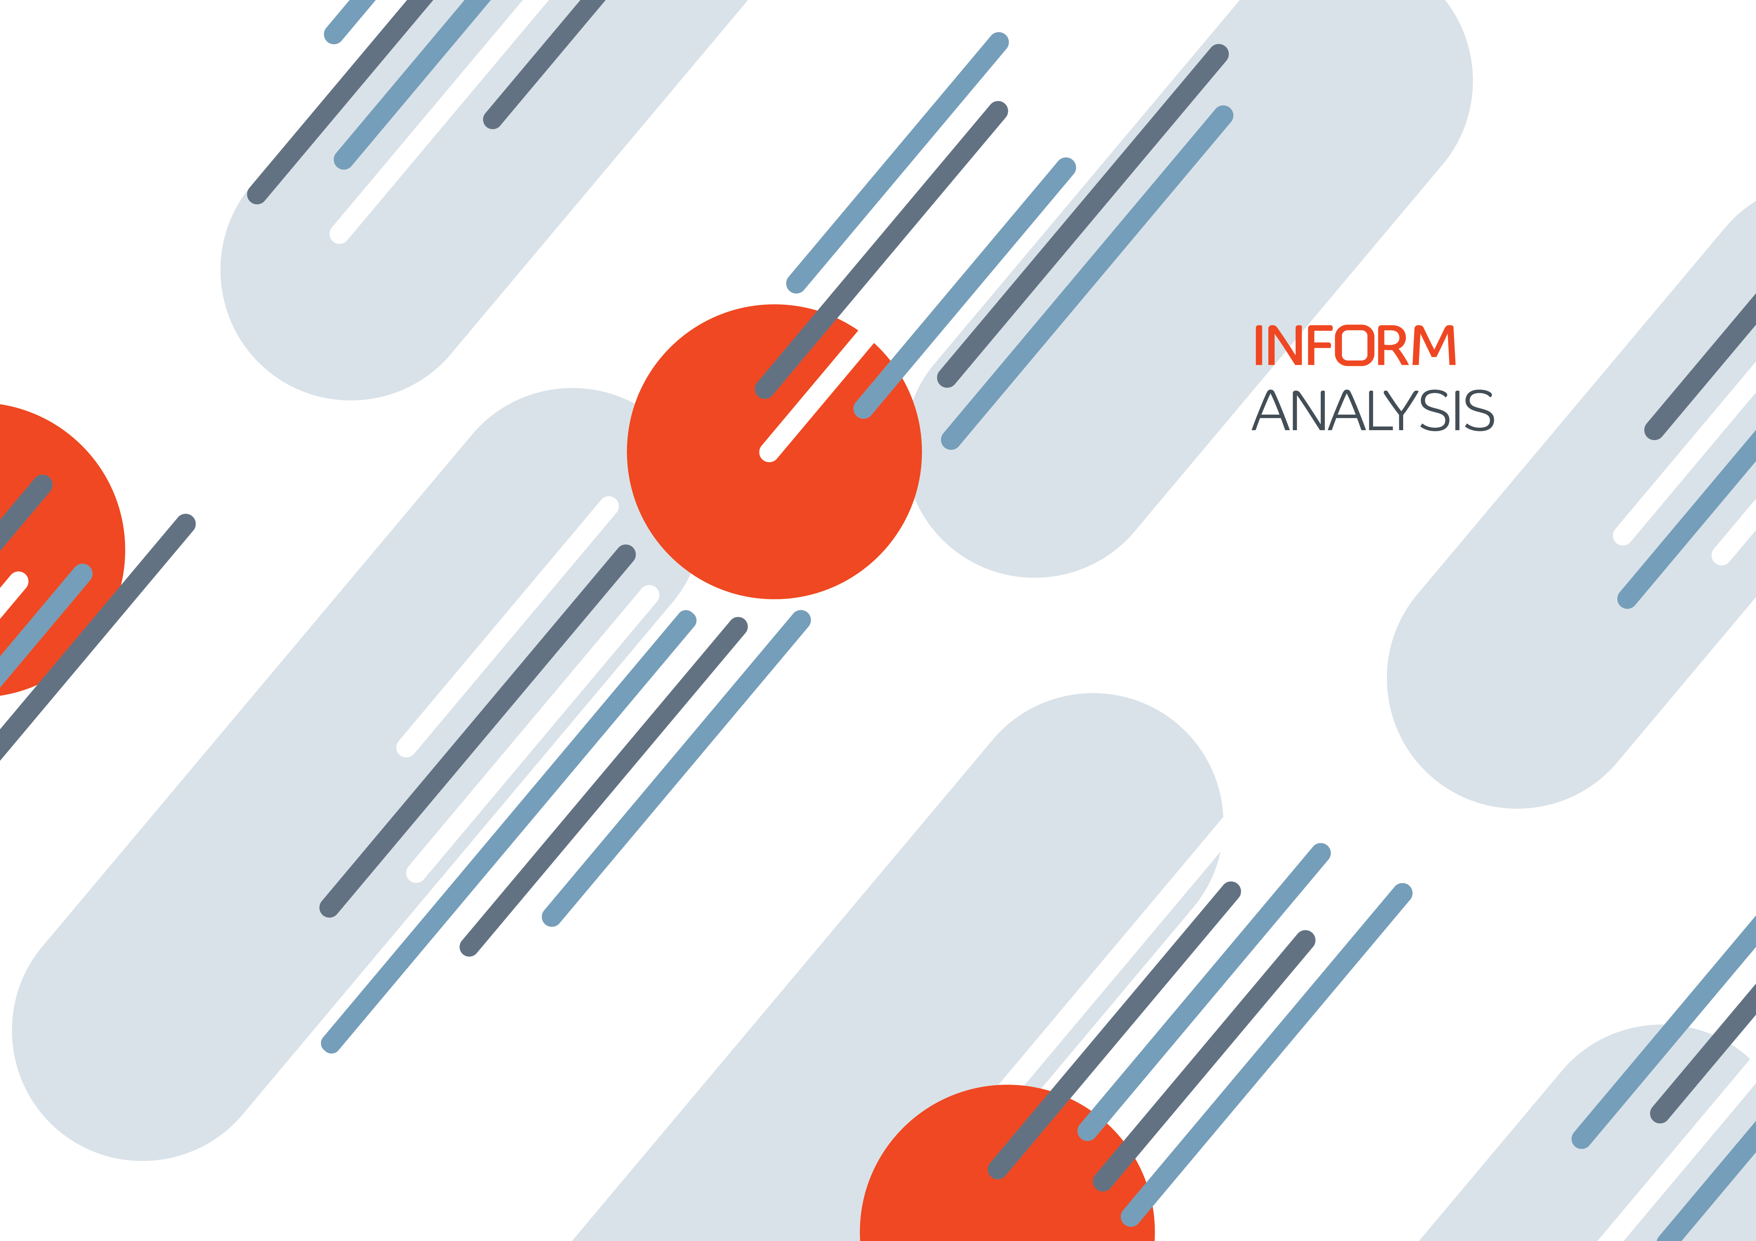

24 25

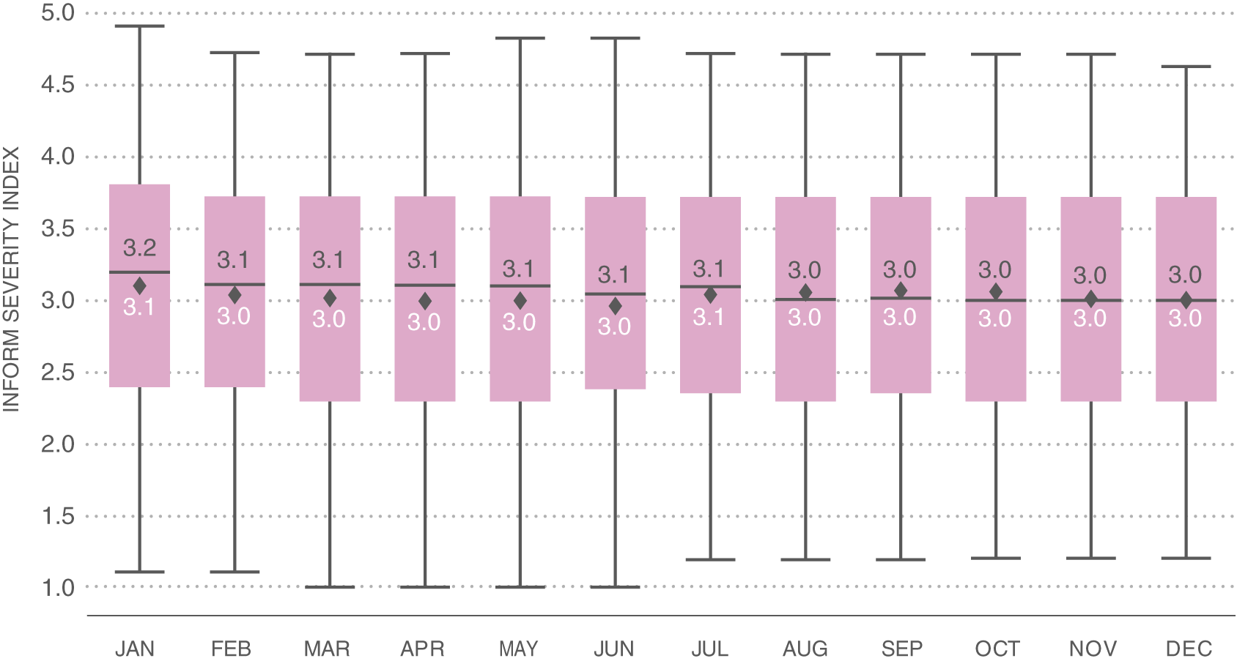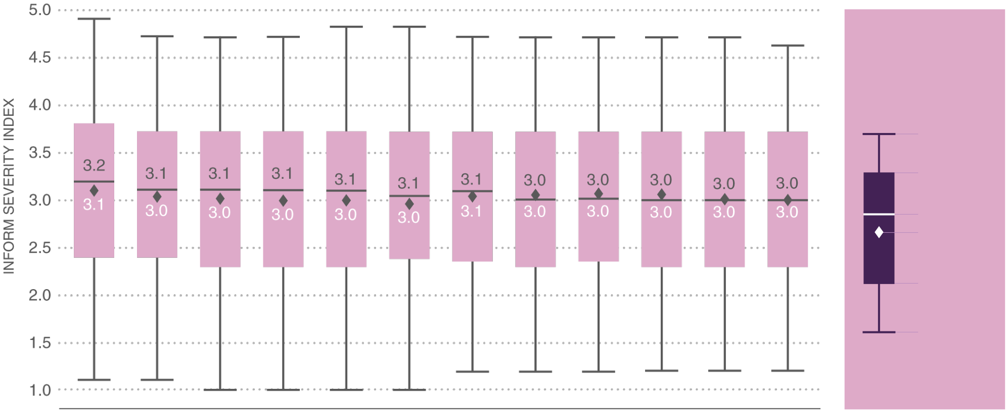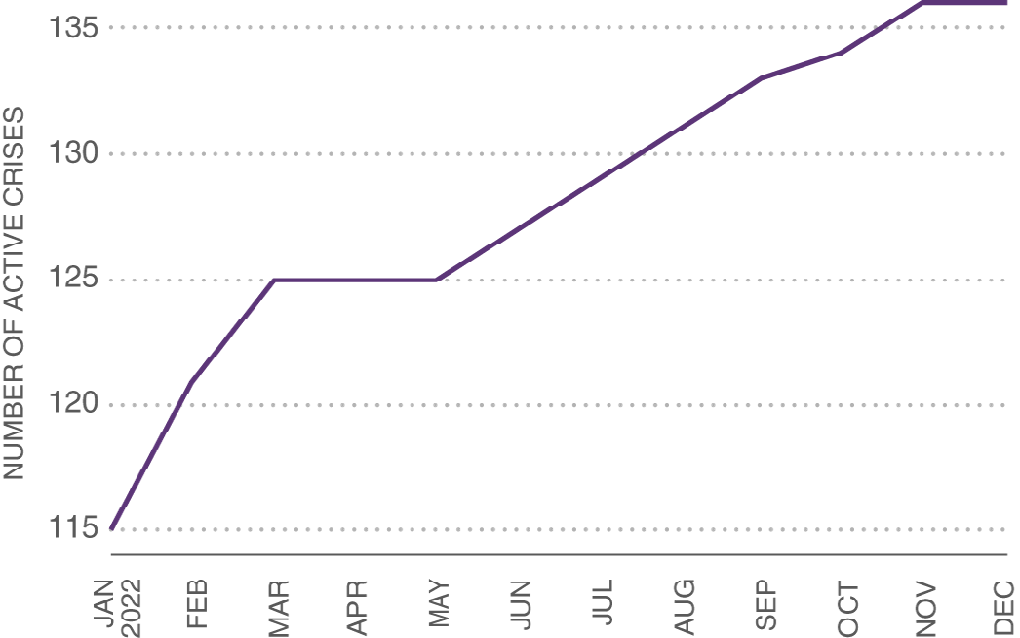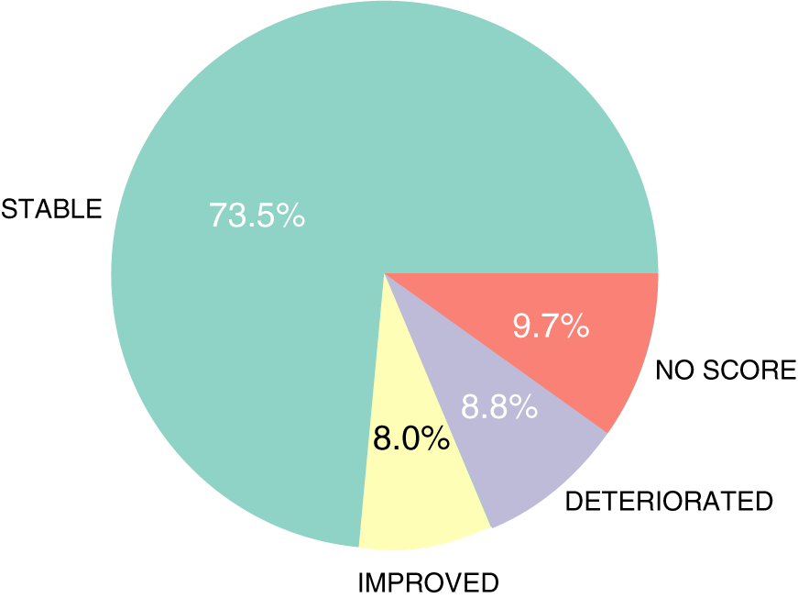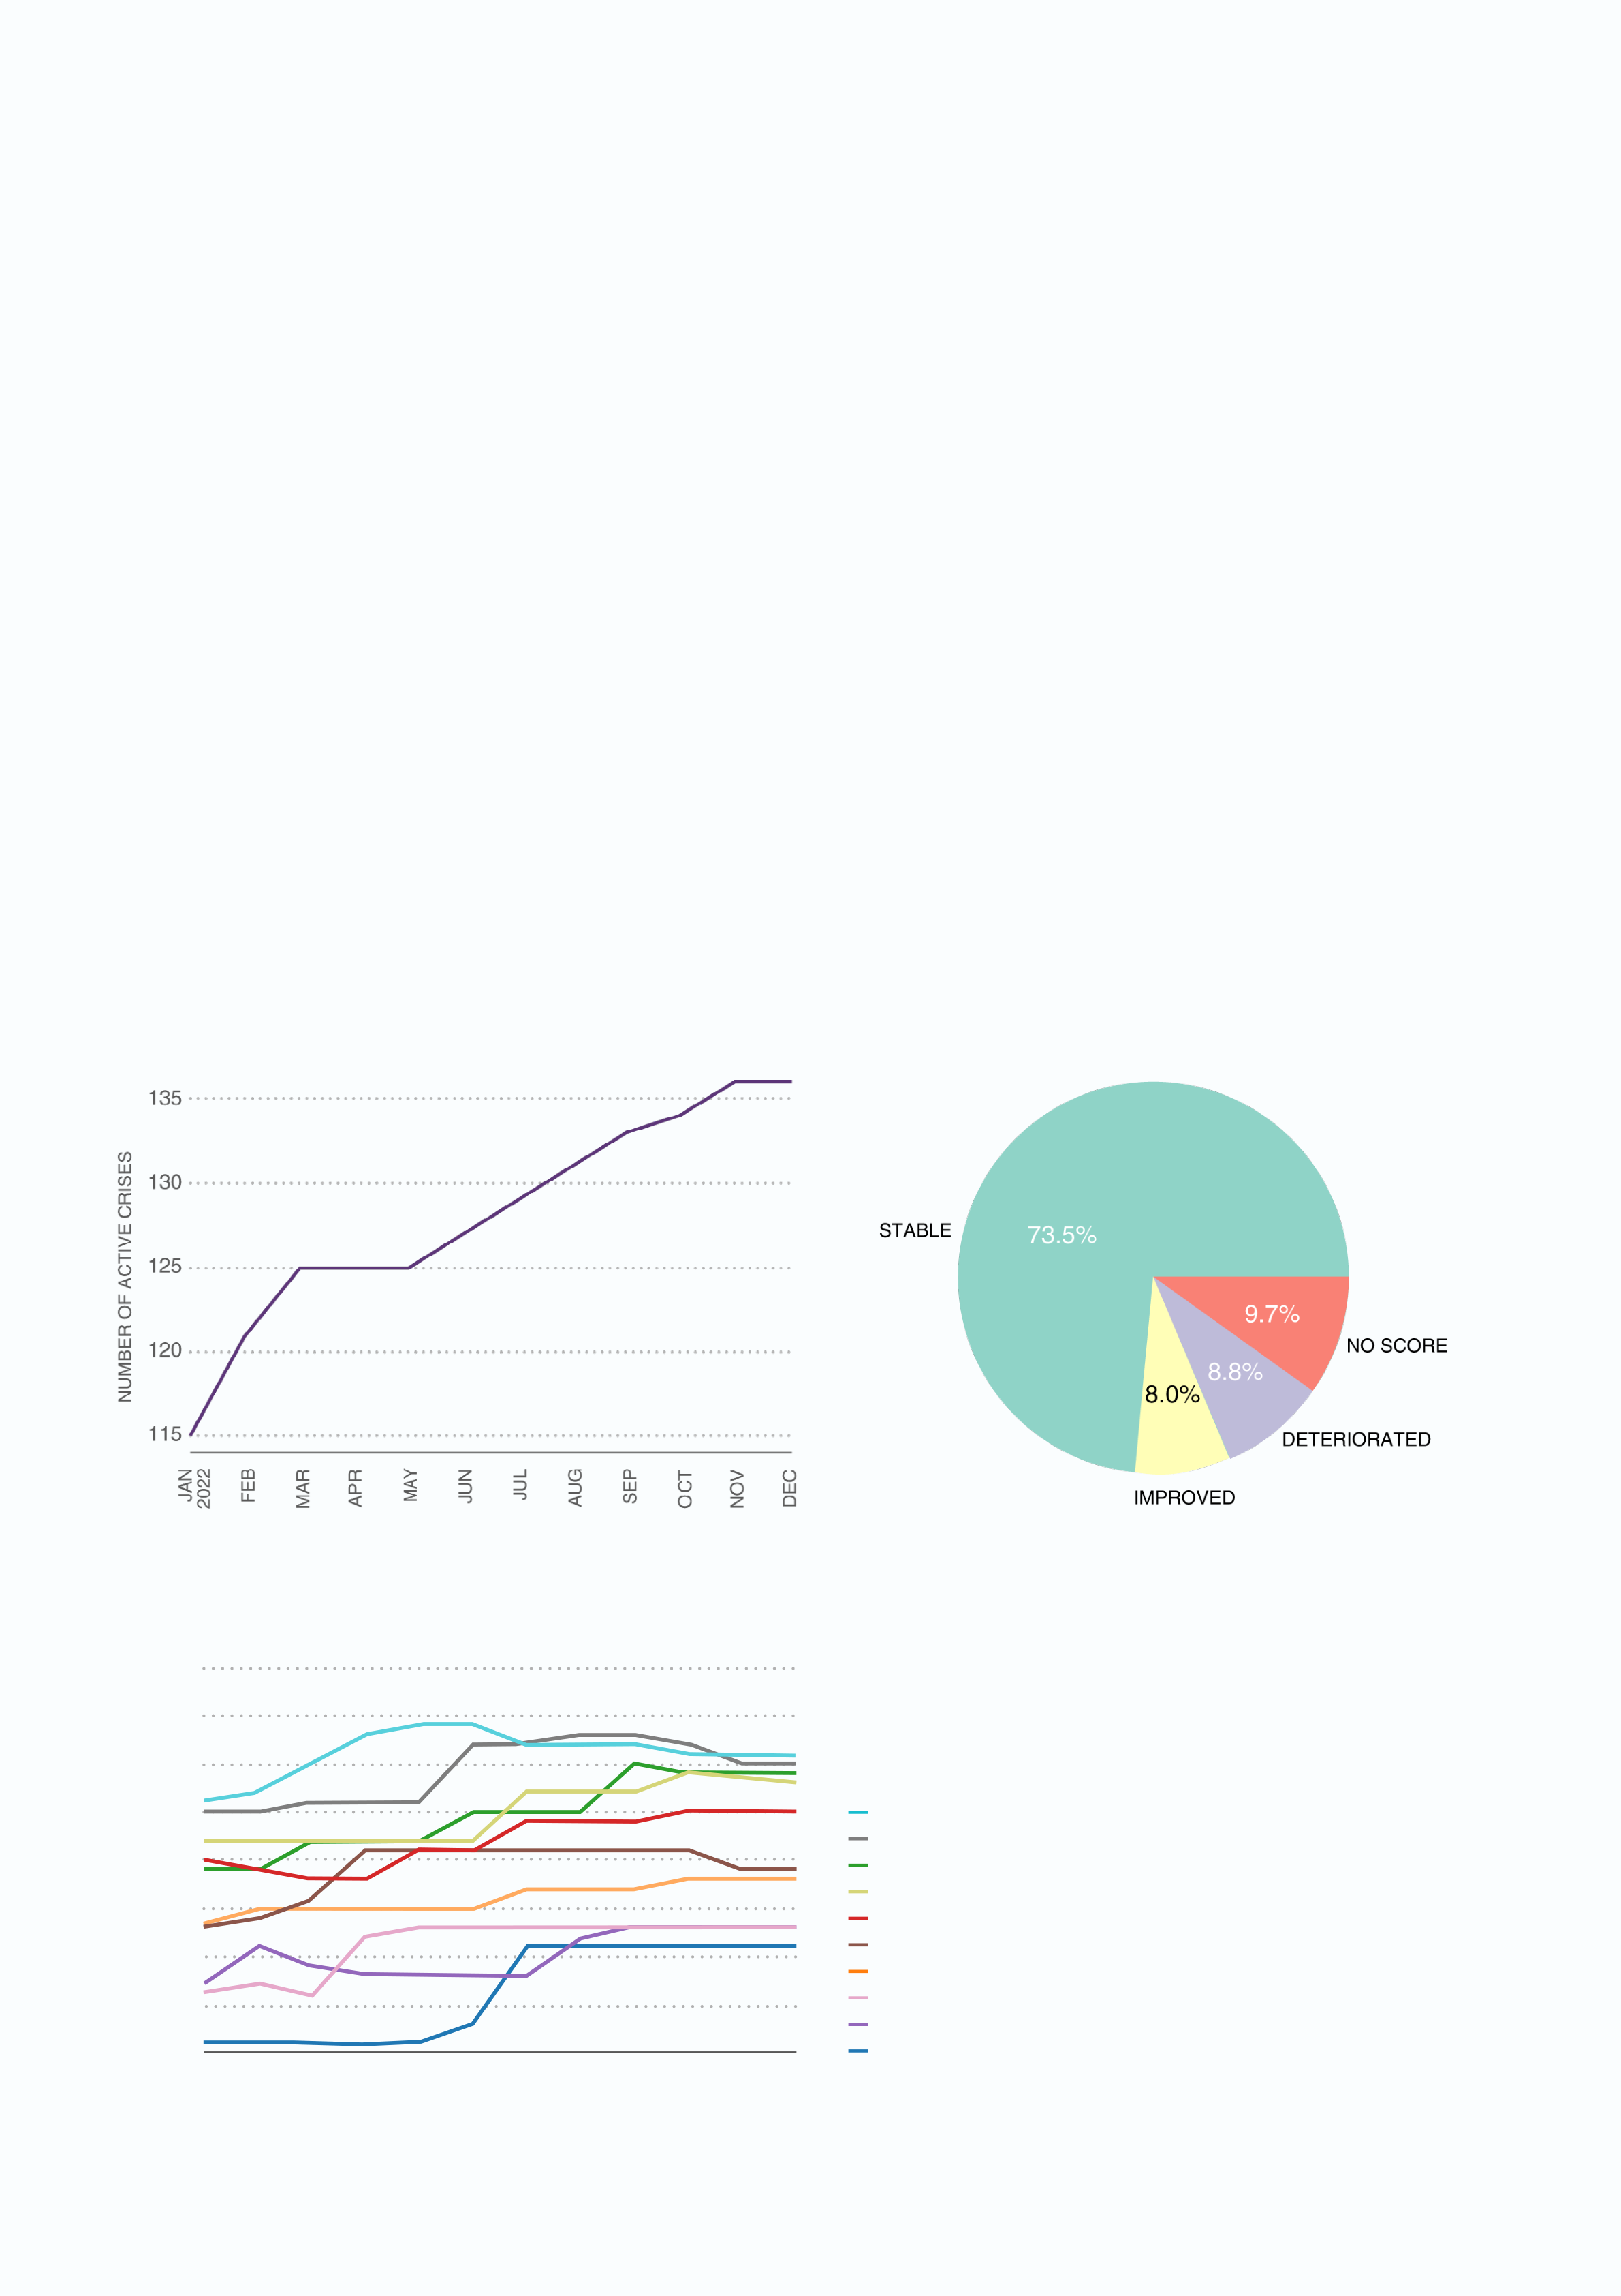

Increasing numbers of crises in 2022

The global average severity score of active crises decreased slightly during 2022, as a result of the low severity of several new crises opened during the year.

**Average Severity Index score of all country-level crises during 2022**

The INFORM Severity Index is released monthly. Here we analyse findings from the Index from calendar year 2022. We   
focus on country-level crises. We use the terms open and closed for crises that, respectively, met or failed to meet the

|  |  |  |
| --- | --- | --- |
| criteria for inclusion in the Index. | KEY | MAX |
| **Number of crises and their severity in 2022** |
| In 2022 the number of crises rose from 115 in January to 136 in December, corresponding to an increase of 18.5%. Most of | Q3 |
| the crises that were included in the Index in January 2021 (113) were still included in December 2021. In addition: | MEDIAN |
| • 23 new crises were opened |
| AVERAGE |

• 2 crises were closed

|  |  |
| --- | --- |
| Of the 115 crises open for the whole year, there were 83 which maintained a stable severity category. 10 crises deteriorated and 9 improved. Crises with significant increases in severity in 2022 included: drought in Kenya; violence in the Darfur and Kordofan regions of Sudan and associated refugee flows into Chad; the conflict in Ukraine; and cyclone seasons in | Q1  MIN |

Madagascar and Mozambique. Several migration and displacement situations also deteriorated markedly, including in   
Costa Rica, Ecuador, Libya and Malaysia.

**Number of crises in the INFORM Severity Index 2022**  **Trends in crisis severity during 2022**

**Regional perspectives**

The majority of the active crises in 2022 were in Africa. Both Europe - mainly due to the escalation of the Ukraine conflict -   
and Asia experienced an increase in the number of active crises.

**Number of crises by region in 2022**

|  |  |  |  |  |  |  |  |  |  |  |  |  |  |  |  |
| --- | --- | --- | --- | --- | --- | --- | --- | --- | --- | --- | --- | --- | --- | --- | --- |
| **Crises with the highest increases in severity in 2022** | | | | | | | | | | | NOV | DEC | Conflict in Ukraine |  | 27 |
| 5.0 | | | | | | | | | | |
| INFORM SEVERITY INDEX | 4.5  4.0  3.5  3.0  2.5  2.0  1.5 | | | | | | | | | |
| Violence in Darfur and Kordofan regions of Sudan |
| Drought in Kenya |
| Darfur refugees in Chad |
| Mixed migration flows in Libya |
| 2022 Tropical Cyclone Seasons in Mozambique |
| Venezuela displacement in Ecuador |
| International Refugees in Malaysia |
| Tropical Cyclones Season in 2022 in Madagascar |
| 1.0 | | | | | | | | | | | Nicaraguan refugees in Costa Rica |
| JAN | | FEB | MAR | APR | MAY | JUN | JUL | AUG | SEP | OCT |
| 26 | | | | | | | | | | |

Risk predicts the likelihood of a crisis and its severity

Here we compare the INFORM Risk Index and INFORM Severity Index results. While the Risk Index can tell us about the

structural risk of crisis in a country and how it evolves over time, the Severity Index tells us how this risk ultimately translates

**Correlation between risk and severity**

The below chart shows the position of countries on a matrix of risk and severity.

Countries that experienced a crisis (INFORM Severity Index Jul-Dec 2022) are shown according to the severity of the crisis and the risk of crisis in the country (INFORM Risk Index 2023). The maximum severity category is shown for countries that experienced more than one crisis. The intensity of the colour shows the number of countries in each position in the matrix (i.e. the correlation between risk and severity).

into an actual crisis. There is a strong correlation between a country’s risk and the severity of a crisis that occurs there. The higher the risk level

**Likelihood of a crisis**  of a country, the more likely it is to have a severe crisis.

From the below chart - a comparison of the INFORM Risk Index 2023 (published September 2022) and results from the   
INFORM Severity Index for Jul-Dec 2022 - we can see that the Risk Index is quite good at predicting the likelihood of a   
crisis. For example:

|  |  |  |  |  |  |  |  |  |  |  |  |  |  |  |  |  |  |  |  |  |  |  |  |  |  |  |  |  |  |  |  |  |  |  |  |  |  |  |  |
| --- | --- | --- | --- | --- | --- | --- | --- | --- | --- | --- | --- | --- | --- | --- | --- | --- | --- | --- | --- | --- | --- | --- | --- | --- | --- | --- | --- | --- | --- | --- | --- | --- | --- | --- | --- | --- | --- | --- | --- |
| • All countries classified as Very High risk experienced a crisis. | | INFORM SEVERITY INDEX ( JULY TO DECEMBER 2022) | |  |  |  |  |  |  | | --- | --- | --- | --- | --- | --- | | **VERY HIGH** |  |  |  | Nigeria, Ukraine | Afghanistan, CAR, Chad, Congo DR, Ethiopia, Haiti, Yemen, Mali, Myanmar, Syria, Somalia, Sudan, South Sudan | | **HIGH** |  | Sri Lanka | Angola, Lebanon, Malawi, North Korea, Palestine,  Peru, Zimbawe,  El Salvador, Türkiye | Bangladesh, Burundi, Colombia, Eritrea,  Guatemala, Honduras, Iran, Libya, Pakistan, Venezuela | Burkina Faso, Cameroon, Iraq, Mozambique, Niger, Kenya, Uganda | | **MEDIUM** |  | Chile, Eswatini,  Hungary,  Malaysia,  Moldova, Poland, Romania, Slovakia | Algeria, Brazil, Costarica,  Djibuti, Dominican Republic, Ecuador, Jordan, Mauritania, Marocco, Namibia, Panama, Rwanda, Senegal, Zambia | Congo, Madagascar, Mexico, Papua New Guinea, Philippines, Tanzania |  | | **LOW** |  | Greece, Italy, Spain, Trinidad and Tobago,  Tunisia | Armenia, Egypt, Gambia, Thailand, Tonga | Azerbaijan |  | | **VERY LOW** |  |  |  |  |  | |  | **VERY LOW** | **LOW** | **MEDIUM** | **HIGH** | **VERY HIGH** | |
| • 90% of High Risk countries experienced a crisis. | |
| • Almost all crises happened in countries classified as Medium to Very High risk. | |
| • No countries in the Very Low risk category experienced a crisis. | |
| **Risk category of countries (according to INFORM Risk Index 2023) where actual crises occurred** | |
| **(INFORM Severity Index Jul-Dec 2022)** | |
|  | |
| **Severity of a crisis**  A comparison of the INFORM Risk and Severity Indexes | **Difference in category between INFORM Risk Index 2023 and INFORM Seveirty Index Jul-Dec 2022** | INFORM RISK INDEX (2022) |
| also allows us to understand the relationship between a country’s risk and the likely severity of an actual crisis.  • 52% of countries had the same Risk and Severity Index category for 2022.  • >97% of countries had a Risk and Severity Index category that was the same or +/- one category. |  | 29 |
| 28 | |

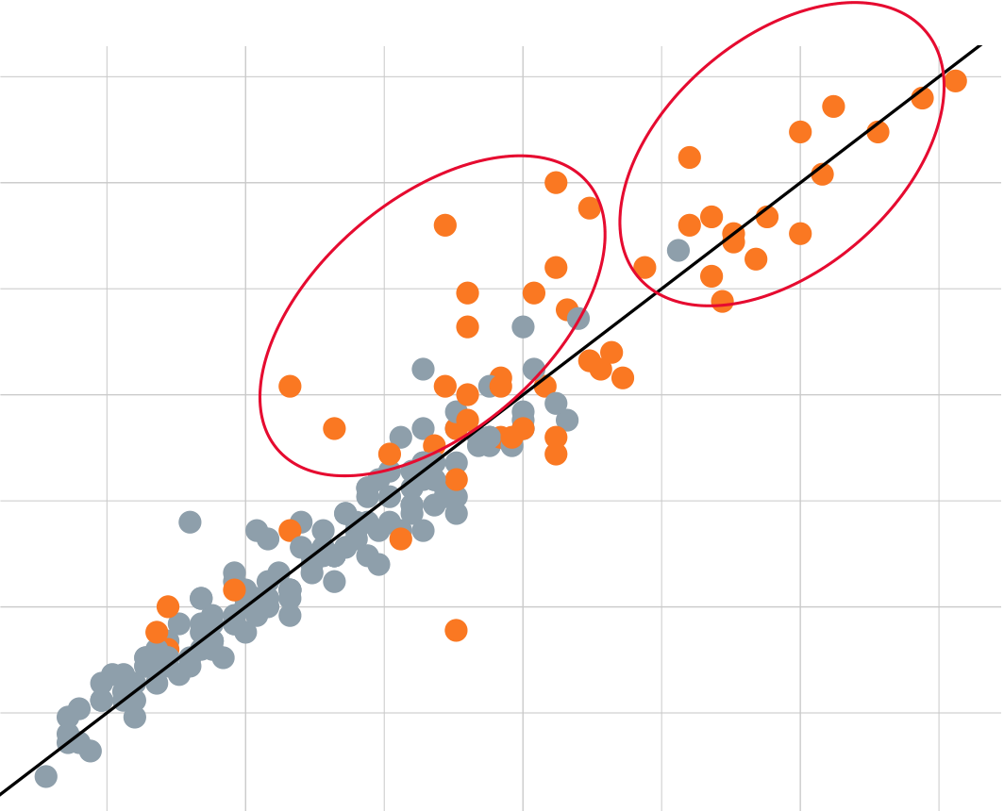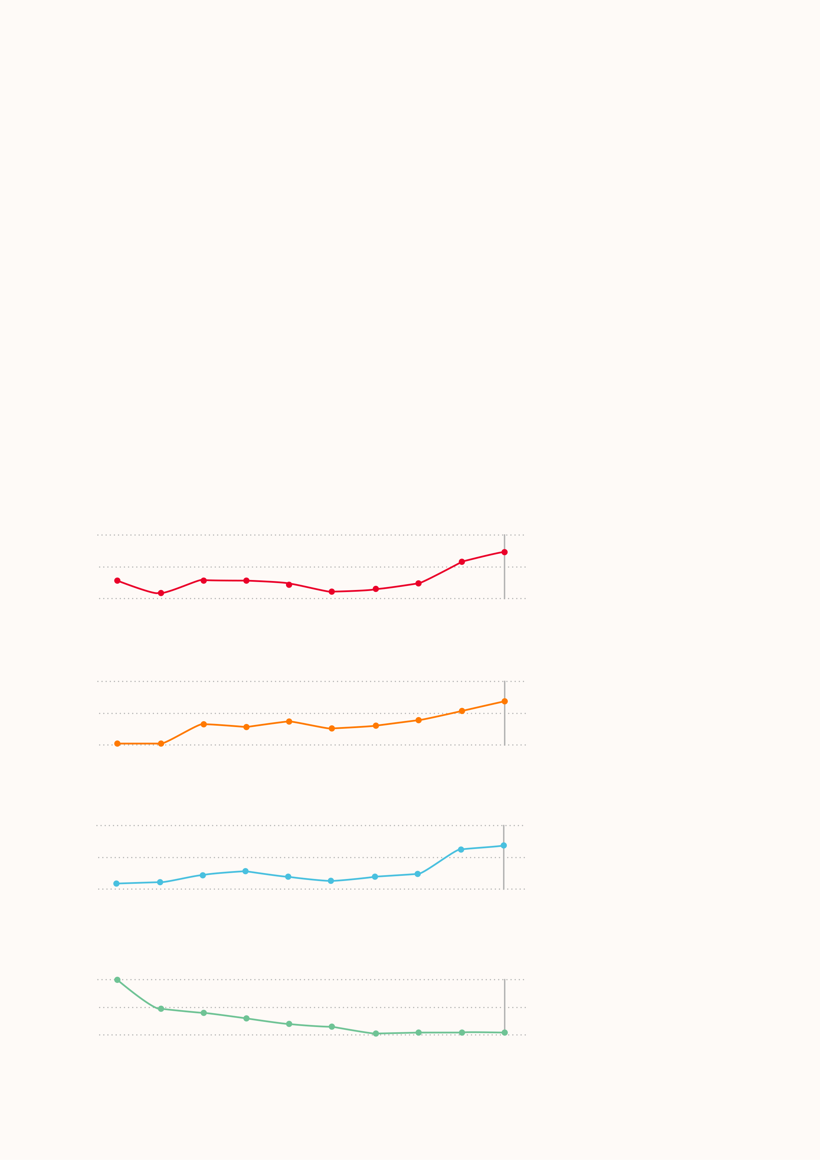

Globally, crisis risk is increasing, despite improvements in coping capacity

Increases in the number of people at risk

In 2023, almost 45 percent of the global population lives in countries classified as having “High” and "Very high" risk of humanitarian crises. In 2014, the proportion was 39 percent. This equates to a 22 percent increase in the absolute number of people. Meanwhile, only 20 percent of the global population lives in countries where the risk is classified as "Low" or

Here we analyse trends in the INFORM Risk Index over the last 10 years of releases (2014-2023). The INFORM Risk Index "Very low".

can be interpreted as the structural risk relating to humanitarian crises. Therefore, it changes quite slowly over time and long-term trends can offer insight into how the structural factors that result in crises are changing over time. Over the last 10 years, we can see some large scale changes in the distribution of risk globally.

**Global trends in crisis risk**

Over the last ten years, there has been a general increase in the risk of humanitarian crises at global level. While there has been an improvement in coping capacity, this has been negated by large increases in the number of people exposed to hazards, and to their vulnerability. In other words, while development of institutions and infrastructure has helped decrease risks, this has not kept pace with the increased exposure to natural hazards and conflict, combined with socioeconomic challenges. Conflict, displacement and shocks like Covid-19 crisis were important drivers of increasing crisis risks in the last decade.

**Global trends in the INFORM Risk Index and its dimensions 2014-2023**

INFORM Risk Index Average Trend

**Population ratio (relative to total population) living in each risk class in 2014, 2019 and 2023**

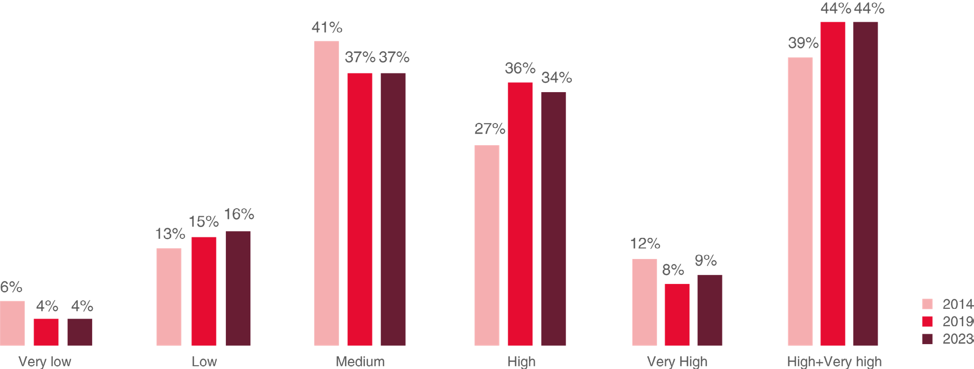

|  |  |  |  |  |  |  |  |  |  |  |  |  |  |  |  |  |  |  |
| --- | --- | --- | --- | --- | --- | --- | --- | --- | --- | --- | --- | --- | --- | --- | --- | --- | --- | --- |
| 3.8 | | | | | | | | 3.63 | 3.65 | 3.71 | 3.75 | Conflict is the main cause of large increases in the risk of crises | | | | | | |
| SCORE | 3.7 | 3.66 | 3.62 | 3.66 | 3.66 | 3.65 | 3.62 |
| 3.6 | | | | | | | | 2020 | 2021 | 2022 | 2023 |
| 2014 | | | 2015 | 2016 | 2017 | 2018 | 2019 |
| Hazard & Exposure Index Average Trend | | | | | | | |
| 3.6 | | | | | | | | 3.32 | 3.35 | 3.41 | 3.47 | Large increases in crisis risk over the last decade are largely correlated to changes in human hazards (conflicts, violence, | | | | | | |
| political instability) (Group 1). With a few exceptions, countries not affected by conflicts experienced far less significant | | | | | | |
| SCORE | 3.4 | 3.21 | 3.21 | 3.33 | 3.31 | 3.34 | 3.3 |
| changes in risk. Likewise, almost all the countries with very high risk levels (Group 2) are those affected by conflict. | | | | | | |
| 3.2 | 2020 | 2021 | 2022 | 2023 | **Change in risk as measured by the INFORM Risk Index between 2014 and 2023. Countries that experienced a** | | | | | | |
| 2014 | | | 2015 | 2016 | 2017 | 2018 | 2019 | **conflict are identified.** | | | | | | |
| Vulnerability Index Average Trend | | | | | | | | 3.68 | 3.7 | 3.85 | 3.87 | INFORM Risk Index 2023  7.5 | Burkina Faso | Niger | Chad | | Somalia | |
| 4 | | | | | | | | South Sudan | |
| Central African Republic | |
| Yemen | Afghanistan |
| SCORE | 3.8 | 3.64 | 3.65 | 3.69 | 3.71 | 3.68 | 3.65 |
| Congo DR | |
| Mozambique | |
| 3.6 | | | | | | | | 2020 | 2021 | 2022 | 2023 | Eritrea | Pakistan | |
| 2014 | | | 2015 | 2016 | 2017 | 2018 | 2019 |
| Lack of Coping Capacity Index Average Trend | | | | | | | | 4.41 | 4.42 | 4.42 | 4.42 | Ukraine | Philippines | | | | | |
| 5.0 | Lebanon | | Egypt | | | |
| Korea DPR | | | | | | |
| 4.8 | | 4.8 | | | | | |
| Algeria | | | | | | |
| Kiribati | | | | | | |
| SCORE | 4.6 | | 4.59 | 4.56 | 4.52 | 4.47 | 4.45 |
| Tunisia | | | | | | |
| 2.5 | **Countries experiencing a conflict or related event, according to the INFORM Severity index** | | | | | |
| 4.4 | | | | | | | |
| 2014 | | | 2015 | 2016 | 2017 | 2018 | 2019 | 2020 | 2021 | 2022 | 2023 | 2.5 | 5.0 | | | 7.5  INFORM Risk Index 2014 | | |
| 30 | | | | | | | | 31 | | | | | | |

Climate change and socio-economic   
trends will increase crisis risks

|  |  |  |
| --- | --- | --- |
| Climate change will increase crisis risks. Under more pessimistic scenarios for | **Countries at risk 2050** | **People at risk 2050** |

greenhouse gas emissions and socio-economic development, by 2050, more

than 1.6 billion people will be living in countries experiencing large increases in

|  |  |  |  |  |  |
| --- | --- | --- | --- | --- | --- |
| the risk of humanitarian crises and disasters (>0.3 point increase in risk score). | Countries at risk 2050 | Countries at risk 2050 | Countries at risk 2050 | People at risk 2050 | People at risk 2050 |

The number of countries classified as having ‘high’ or ‘very high’ crisis risk will

increase from 36 today to 52 (45%).

|  |  |  |  |  |  |  |  |  |  |  |  |  |  |  |  |  |  |  |  |  |  |  |  |  |  |  |  |  |  |  |  |  |  |  |  |  |  |  |  |  |  |  |
| --- | --- | --- | --- | --- | --- | --- | --- | --- | --- | --- | --- | --- | --- | --- | --- | --- | --- | --- | --- | --- | --- | --- | --- | --- | --- | --- | --- | --- | --- | --- | --- | --- | --- | --- | --- | --- | --- | --- | --- | --- | --- | --- |
| More than 5.5 billion people – almost double the number today – will be living | 17 | | | 17 | | | | | | | | | | 17 | | | | | | | | | | 1.53 | | | | | | | | | | | | | 1.53 | | | | | |
| in these countries, which today account for almost all humanitarian crises, and Very High | Very High 16 | | | 16 | | | | | Very High | | | | | 16 | | | | | | | | | | Very High | | | | | 1.04 Very High | | | | | | | | 1.04 | Very High | | 1.04 | | |
| in 2022 resulted in 274 million people in need of humanitarian assistance and | 14 | | | 14 | | | | | | | | | | 14 | | | | | | | | | | 0.58 | | | | | | | | | 0.58 | | | | | | 0.58 | | | |
| financial requirements of US$41 billion. |
| The number of people living in ‘very high’ crisis risk countries will roughly triple INFORM CLIMATE CHANGE RISK INDEX CATEGORY from 580 million to 1.5 billion.  High Even under more optimistic scenarios, there will be significant increases in the number of people annually affected by crises and the costs of helping them as we progress towards 2050.  Medium  Low | INFORM CLIMATE CHANGE RISK INDEX CATEGORY | High | | | 26 | 35 | INFORM CLIMATE CHANGE RISK INDEX CATEGORY   26 High  22  48  Medium 55  53  Low | | | | | | 35 | | 63 | | 48 | | | 22 | | 26 | | 63 | 35 | GORY | High | | 55 | 60 | INFORM CLIMATE CHANGE RISK INDEX CATEGORY   |  | | --- | | 63 | | 64 | | | |  | | --- | | High | | | | INFORM CLIMATE CHANGE RISK INDEX CATEGORY 3.03  2.42  2.69  2.56  2.74  1.29  1.51  1.37 | | | 4.14 | | | |
| ATE | High | 3.03 | | |
| 22 | | | X C | 48 | | |  | | --- | | Medium | | | | 2.42 | | | |
| Medium | | | 55 | | RISK INDE | 2.69 | | | |
| GE | Medium | | Medium 2.56 | | | |
| Low | | | 60 | | 53 | | 60 | | HAN | Low | | |  | | --- | | 53 | | 1.29 | | | 2.74 | | | |
| LIMATE C | Low | | | |
| M C | 1.51 | | |
| 64 | | 64 | INFOR | 1.37 | | |
| |  | | --- | | 31 | | | | | | | | | | 31 | | | | | 31 | | | | | | | | | | | | | | | 0.166 | | | | 0.166 | | | | 0.166 | | | | | |
| Very Low | Very Low | | | |  | | --- | | 31 | | | | | | Very Low | | | 31 | | 31 | | | | | | | | | | | | Very Low | | | 0.187 | | | Very Low | | | 0.187 | | Very Low | | | 0.187 | | |
| |  | | --- | | 38 | | | | | | | | | | | | | | | 38 | | | | | | | | | | 38 | | | | | 0.199 | | | | 0.199 | | | | 0.199 | | | | | |
| 0 | 10 | 20 | 0 | | 30 | 10 | 40 | 20 | 50 | 30 | 0 | | 60 | 40 | | 10 | 70 | 50 | 20 | | 60 | | 30 | 70 | | 40 | 50 | 0 | 60 | | 1 | | 70 | 2 0 | | | 3 1 | 4 2 | 0 | 5 3 | 1 | 6 4 |
| NUMBER OF COUNTRIES | | | | | | | | NUMBER OF COUNTRIES | | | | | | | | | | NUMBER OF COUNTRIES | | | | | | | | | | | TOTAL NUMBER OF PEOPLE (BILLIONS) TOTAL NUMBER OF PEOPLE (BILLIONS | | | | | | | | | | | | | |
| 2050 Pessimistic (RCP8.5-SSP3) 2050 Pessimistic (RCP8.5-SSP3) 2050 Optimistic (RCP4.5-SSP1) 2050 Pessimistic (RCP8.5-SSP3) 2050 Optimistic (RCP4.5-SSP1) Baseline (Current) | | | | | | | | | | | | | | | | | | | | | | | | 2050 Optimistic (RCP4.5-SSP1) | | | | | | | | | Baseline (Current) | | | | | | | | | |

|  |  |
| --- | --- |
| *Number of countries in each category of the INFORM Climate Change Risk Index* | *Number of people living in countries classified according to the INFORM Climate* |

|  |  |  |
| --- | --- | --- |
| 32 | *in mid-century (2050), taking into account the effects of climate change and socio-* | *Change Risk Index in mid-century (2050), taking into account the effects of climate* |
| *economic trends. Shown are the pessimistic scenario for 2050, optimistic scenario for* | *change and socio-economic trends. Shown are the pessimistic scenario for 2050,* |
| *2050 and the baseline (current) risk.* | *optimistic scenario for 2050 and the baseline (current) risk.* |
| 33 |

Africa and low income countries will be worst affected by increasing climate change-related crisis risk

Crisis and disaster risks will increase in all regions, regardless of climate and socio-economic scenarios.

However, certain regions – especially Africa – will be worst affected. The countries likely to be hit hardest are generally located in Western, Southern and Eastern Africa. Other regions of Africa, Central and South America, and Western and Southern Asia also face increasing risks.

Lower income countries will be worst affected. While higher income countries may be able to absorb increases in risk, more than 70% of countries with large predicted increases will not have the resources to cope. This will especially be the case in low and lower-middle income countries, particularly in Africa.

Without increased efforts and resources to reduce vulnerability and increase coping capacity in these countries, they will face significant increases in crisis-related human and economic losses, which will further set back development.

CHANGE IN RISK BY SUB-REGION 2050

**Change in risk by sub-region 2050 (pessimistic scenario RCP8.5-SSP3)**

|  |  |  |  |  |
| --- | --- | --- | --- | --- |
| STABLE | SMALL INCREASE | INCREASE | LARGE INCREASE |  |

|  |
| --- |
| Western Africa |

|  |  |
| --- | --- |
| Southern Africa |  |
| Eastern Africa | Africa |

|  |
| --- |
| Northern Africa |

|  |
| --- |
| Middle Africa |

Central America

|  |  |
| --- | --- |
| South America |  |
| Northern America | Americas |

Carribean

|  |
| --- |
| Western Asia |

|  |  |
| --- | --- |
| Central Asia |  |
| Southern Asia | Asia |

|  |
| --- |
| South-Eastern Asia |

|  |
| --- |
| Eastern Asia |

Eastern Europe

|  |  |
| --- | --- |
| Southern Europe |  |
| Western Europe | Europe |

Northern Europe

|  |  |
| --- | --- |
| Micronesia |  |
| Australia / New Zealand | Oceania |

|  |
| --- |
| Melanesia |

|  |  |  |  |  |  |  |  |
| --- | --- | --- | --- | --- | --- | --- | --- |
| Polynesia | 0 | 0.1 | 0.2 | 0.3 | 0.4 | 0.5 | 0.6 |

AVERAGE CHANGE IN RISK

34

|  |
| --- |
| Vulnerability gap by region 2050  Vulnerability gap by region 2050 |

|  |  |  |  |  |  |  |
| --- | --- | --- | --- | --- | --- | --- |
| **Vulnerability gap by region 2050** | | | |  |  |  |
| AVERAGE VULNERABILITY GAP 2050 AVERAGE VULNERABILITY GAP 2050 | 0.9  0.9  0.8  0.8  0.7  0.7  0.6  0.6  0.5  0.5  0.4  0.4  0.3  0.3  0.2  0.2  0.1  0.1 | | |
| ASIA ASIA | OCEANIA  OCEANIA | EUROPE  EUROPE |
| 0  0 | | AFRICA AFRICA | AMERICA  AMERICA |
| 2050 Optimistic (RCP4.5-SSP1) 2050 Optimistic (RCP4.5-SSP1) | | | | 2050 Pessimistic (RCP8.5-SSP3) 2050 Pessimistic (RCP8.5-SSP3) | |

*Average Vulnerability gap by region. The Vulnerability gap shown is for mid-century (2050) relative to the baseline (current) risk, under the pessimistic climate and socio-economic scenario.*

|  |  |  |  |  |  |
| --- | --- | --- | --- | --- | --- |
| **Vulnerability gap by income group 2050**  Vulnerability gap by income group 2050 Vulnerability gap by income group 2050 | | | | | |
| AVERAGE VULNERABILITY GAP 2050 AVERAGE VULNERABILITY GAP 2050 | 0.9  0.9  0.8  0.8  0.7  0.7  0.6  0.6  0.5  0.5  0.4  0.4  0.3  0.3  0.2  0.2  0.1  0.1 | | | | |
| 0  0 | | LOW  INCOME LOW  INCOME | LOWER MIDDLE LOWER MIDDLE INCOME   INCOME | UPPER MIDDLE UPPER MIDDLE INCOME   INCOME | HIGH  INCOME HIGH  INCOME |
| 2050 Optimistic (RCP4.5-SSP1) 2050 Optimistic (RCP4.5-SSP1) | | | | 2050 Pessimistic (RCP8.5-SSP3) 2050 Pessimistic (RCP8.5-SSP3) | |

*Average Vulnerability gap by income-group. The Vulnerability gap shown is for mid-century (2050) relative to the baseline (current) risk, under the pessimistic climate and socio-economic scenario.*

35

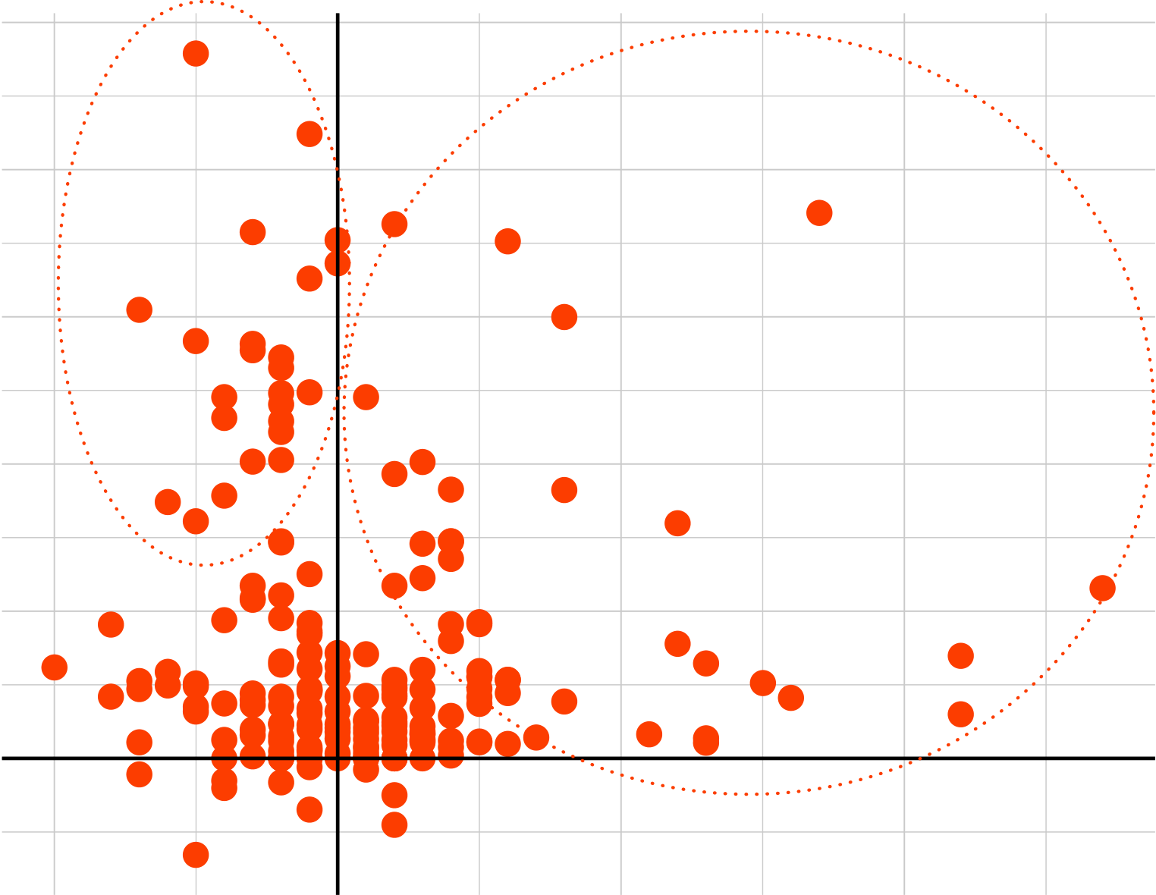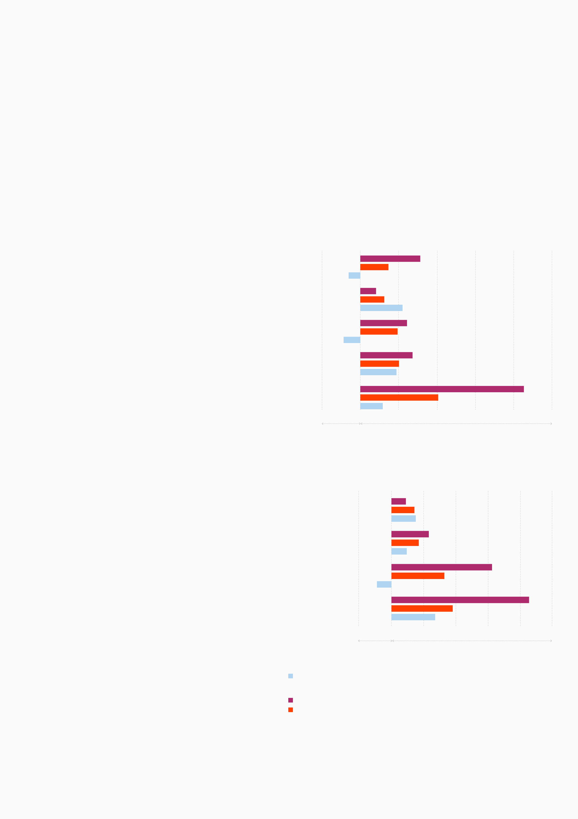

|  |  |  |  |
| --- | --- | --- | --- |
| Looking back, looking forward | | Crisis risk trajectories | • Firstly (Group 1), countries that have struggled with |
| **Historical risk trends and climate** | **Regional and income class overview of recent crisis risk** | **Getting on the right path** |
| **change**  Here we combine analysis of risk trends over the last decade from the INFORM Risk Index with estimates of | **trends (2014-2013 INFORM Risk Index) and future Change in risk and Vulnerability gap in 2050 (INFORM Climate Change, Pessimistic scenario combination RCP8.5-SSP3)**  **Looking back**   Change in risk 2014-2023 |
| Analysing past and future risk trends of individual countries |
| increases in crisis risk over the last ten years AND are |
| can help us understand how well placed they are to cope |
| facing high vulnerability gaps in the future as a result of |
| with future crisis risks. Here we compare risk trends over |
| climate change. These countries will require particularly |
| how risk will change in the future from INFORM Climate | **Looking forward** | the last 10 years from the INFORM Risk Index with the |
| high adaptation efforts to mitigate future crisis risks. |
| Change. The crisis risk pathway of individual countries in recent years influences how they will be able to cope with | Vulnerability gap in 2050 Pessimistic (RCP8.5-SSP3) Regional overview Change in risk in 2050 Pessimistic (RCP8.5-SSP3) | vulnerability gap in 2050 from INFORM Climate Change. |
| The vulnerability gap represents the amount of adaptation | • Secondly, (Group 2), countries that are facing a high |
| future climate challenges. | | (vulnerability reduction, coping capacity increase) that will |
| vulnerability gap in the future but have made reductions |
| 35 | | be required to maintain the current level of risk. We can |
| Oceania | | in crisis risk over the last decade. This could suggest that |
| identify two groups of countries of interest. |
| **Risk increase in Africa and low income** | | these countries are on a good risk reduction trajectory, |
| although they will require continued improvements to |
| **countries** | Europe | cope with future crisis risks. |

From a comparison between regions and income groups

|  |  |  |  |  |  |  |  |  |  |  |  |  |  |  |  |  |  |  |  |  |
| --- | --- | --- | --- | --- | --- | --- | --- | --- | --- | --- | --- | --- | --- | --- | --- | --- | --- | --- | --- | --- |
| of recent past and future risk trends, several points | Asia | | 0 | 0.2 | 0.2 | 0.4 | 0.6 | 0.6 | 0.8 | 1 | **Comparison of recent crisis risk trends (2014-2013 INFORM Risk Index) and future vulnerability gap in 2050** | | | | | | | | | |
| emerge: |
| **(INFORM Climate Change, Pessimistic scenario combination RCP8.5-SSP3) for individual countries** | | | | | | | | | |
| • On average, countries in Asia and Oceania were able | 23 | |
| Americas | 23 | 2.5  Vulnerability gap in 2050 Pessimistic (RCP8.5−SSP3)  2.0  1.5  1.0  0.5 | Group 2 | | Angola | Burundi | Tanzania | Group 1 | Eritrea | Niger | Burkina Faso |
| to reduce their crisis risk over the last decade. If these | 30 | |
| countries continue their progression, they will have | Africa | |
| less difficulty facing the increasing risks that come with | Guinea−Bissau | |
| climate change. However, where climate adaptation |
| -0.2 | 0 |
| strategies are weak, this progress could be negated by |
| Lesotho | |
| climate impacts. | Decrease | | Increase |
| • Despite some improvements in coping capacity, |
| Benin | |
| Africa and low income countries largely failed to tackle | Income class overview | | 23 | 0.4 | 0.8 | 1 | Zambia | Mozambique |
| Liberia | |
| increasing crisis risks in the last decade. 6 out of 10 |
| Kiribati | Togo |
| countries with largest increases in risk during last 10 |
| years are located in Africa. | Gambia | Malawi |
| High income | |
| • Africa and low income countries are worst affected by |
| climate-related crisis risks. This is true in terms of both |
| Upper middle income | |
| the likely increase in risk and the highest vulnerability |
| gap. The latter represents the amount of vulnerability |
| reduction and coping capacity increase that would |
| Lower middle income | |
| be required to maintain the current level of crisis risk. |
| Therefore, they will require the largest investments |
| in crisis prevention and risk management to avoid |
| Low income | | Ukraine |
| potentially devastating risk increases in future. |
| 23 |
| 0.0 |
| -0.2 | |
| Decrease | | Increase | −1 | | 0 | 1 | | | 2  Change in risk 2014−2023 | | | |
| **Looking back** | |
| Change in risk 2014-2023 | |
| **Looking forward** | |

Vulnerability gap in 2050 Pessimistic (RCP8.5-SSP3)   
Change in risk in 2050 Pessimistic (RCP8.5-SSP3)

35   
Oceania

36 37

Europe

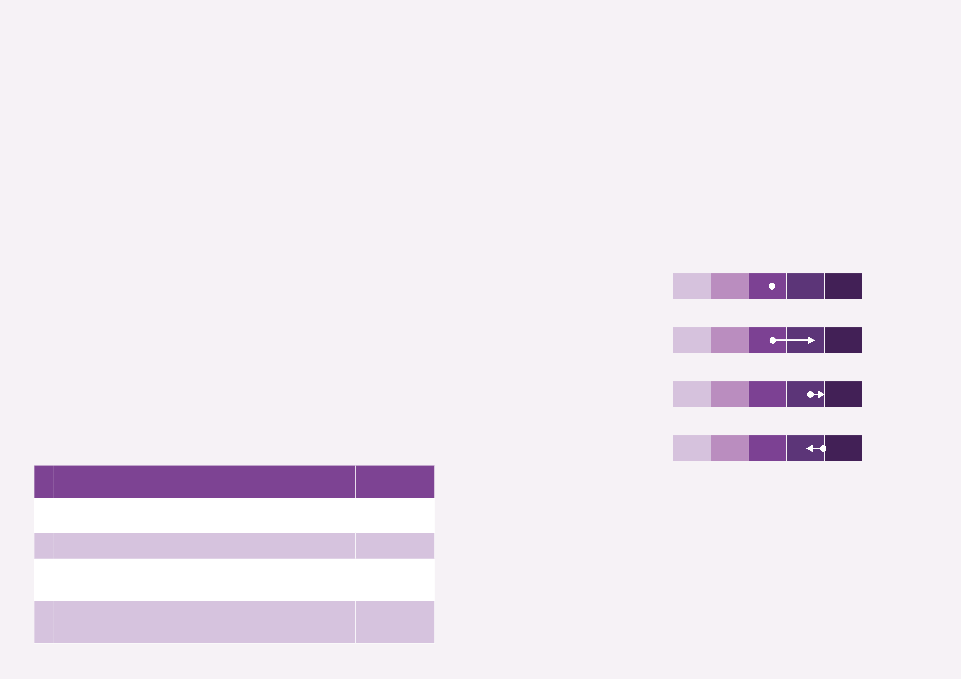

Research example:   
Quantifying future crisis severity in Ethiopia

**Increasing drought-related humanitarian needs**

The current drought in Ethiopia, the worst since 1984, coupled with the Russian invasion of Ukraine are estimated to have increased the number of food insecure in the drought-affected regions from 0.3M people in February 2022 to 12M in February 2023. The resulting 2022 Humanitarian Response Plan (HRP) had 3.09B USD in requirements, about double the amount allocated in each of the past 5 years. The Drought Response Plan (DRP), which represents 1.66B USD of the HRP, targeted 17M people, of which 9.9B were facing Crisis, Emergency, or Famine (High acute malnutrition or higher). About 98 USD is allocated per person facing high acute malnutrition or higher.

**Climate change mitigation and sustainable agriculture reduce future aid needs**

The results of this analysis show how different climate change and agricultural practices affect future crisis severity and funding requirements. High greenhouse gas emissions scenarios combined with non-sustainable agricultural practices lead to significant future increases in drought-related crisis severity and needs in Ethiopia. Conversely, more moderate greenhouse gas emissions and sustainable agriculture lead to more modest increases, comparable with current conditions.

Improving and implementing climate policies that focus on mitigation and reduction of carbon emissions and agricultural policies that focus on sustainable practices will therefore have substantial positive consequences on food security and future

**RECEIPT project and storylines**  aid needs.

The European Union Horizon 2020 funded project RECEIPT (Remote climate effects and their impact on European

sustainability, policy and trade) acts to assess remote climate change impacts on a variety of European risks including those related to agriculture and food production, finance, foreign cooperation and development, global manufacturing chains, and

**Impact of the assessed scenarios on the INFORM Severity Index**

|  |  |  |  |  |  |  |  |  |
| --- | --- | --- | --- | --- | --- | --- | --- | --- |
| coastal infrastructure. These risks in RECEIPT are assessed using a concept called storylines, i.e., physically self-consistent | FACTUAL - February 2022 | **INFORM Severity Index** | | | | | **Very High** | |
| cause-effect pathways of past events or plausible future events to evaluate the effects of a wide variety of factors, including |
| those related to climate change hazards, climate change adaptation measures, and socioeconomics. | **Very Low** | | **Low** | **Medium** | **High** |
| **Storyline development and the INFORM Severity Index** |
| In this storyline, a team from the Risk Assessment and Adaptation Strategies division at the Euro-Mediterranean Center | early drought event prior to the conflict | **0** | **1** | | **2** | **3** | **4** | **5** |
| on Climate Change explored the extent to which food crises may become more severe under future climate change is | in Ukraine |
| explored with the aim to understand how food crises can be prevented by food security policies and European development |
| co-operations and development aid. The role of climate and population change is considered using FAO food security |
| projections (RCP4.5-TSS and RCP-8.5-SSS) and UN population projections. The number of food insecure people is | February 2023 | **0** | **1** | | **2** | **3** | **4** | **5** |
| integrated into the INFORM Severity framework which can be used to provide guidance for decisions regarding humanitarian |
| severe drought and conflict in Ukraine |
| aid. |
| **Quantifying future changes in crisis severity and funding requirements** |

In a food insecurity crisis, INFORM Severity Index considers people in need (PIN) of humanitarian assistance as people

|  |  |  |  |  |  |  |  |  |  |  |  |  |  |
| --- | --- | --- | --- | --- | --- | --- | --- | --- | --- | --- | --- | --- | --- |
| under stress levels 3, 4 and 5, which according to the (IPC, 2004) classifications are in a situation of crisis (3), emergency (4) and famine (5). In this analysis, the impact of climate change and agricultural practices on drought-related crisis needs are assessed. The number of people in need are estimated and are integrated into the INFORM Severity Index, to understand possible future changes in crisis severity. An estimate of drought response funding requirements is made based on the per person allocation from the 2022 DRP.  **Scenarios assessed and their impacts on people in need (PIN), funding requirements and INFORM Severity Index value** | | | | | | | 2050  high greenhouse gas emissions (RCP8.5)  and non-sustainable agricultural practices | | | | | | |
| (Stratified Society Scenario) | **0** | **1** | **2** | **3** | **4** | **5** |
| 2050  mid-range greenhouse gas emissions  (RCP4.5) and sustainable agricultural | | | | | | |
| **Scenario** | | **People in need** | | | **Funding requirements** | **INFORM Severity** | practices (Towards Sustainablity Scenario) | **0** | **1** | **2** | **3** | **4** | **5** |
| **based on adjustment**  **of 2022 DRP** | | | | | | **Index** | Further information:  <https://climatestorylines.eu/>  Bovienzo, D., Marzi, S., Monteleone, L., Mysiak, J., and Pal, J.: Current and future evolution of drought risk in Ethiopia: A framework to inform disaster risk reduction and climate change adaptation policies , EGU General Assembly 2023, Vienna, Austria, 24–28 Apr 2023, EGU23-14314, https://doi.org/10.5194/egusphere-egu23-14314, 2023.  J.J.M. van den Hurk, B., Baldissera Pacchetti, M., Boere, E., Ciullo, A., Coulter, L., Dessai, S., Ercin, E., Goulart, H.M.D., Hamed, R., Hochrainer-Stigler, S., Koks, E., Kubiczek, P., Levermann, A., Mechler, R., van Meersbergen, M., Mester, B., Middelanis, R., Minderhoud, K., Mysiak, J., Nirandjan, S., van den Oord, G., Otto, C., Sayers, P., Schewe, J., Shepherd, T.G., Sillmann, J., Stuparu, D., Vogt, T., Witpas, K., 2023. Climate impact storylines for assessing socio-economic responses to remote events. Clim. Risk Manag. 40, 100500. https://doi.org/https://doi. | | | | | | |
| 1 | FACTUAL – February 2022 – early | 300,000 | | | | 2.7 (Medium) |
| drought event prior to the conflict in  Ukraine | | | | | | |
| 2 | February 2023 – severe drought and | 12 million | USD 1 .2 billion | | | 3.7 (High) |
| conflict in Ukraine | | | | | | |
| 3 | 2050 – high greenhouse gas emissions | 25.5 million | | USD 2.5 billion | | 4.0 (Very High) |
| (RCP8.5) and non-sustainable  agricultural practices (Stratified Society  Scenario) | | | | | | |
| 4 | 2050 – mid-range greenhouse gas | 4.7 million | USD 0.8 billion | | | 3.5 (High) |
| emissions (RCP4.5) and sustainable  agricultural practices (Towards Sustain- ability Scenario) | | | | | | |

org/10.1016/j.crm.2023.100500

38 39



INFORM is a collaboration of the Inter-Agency Standing Committee and the European Commission. The Joint Research Centre of the European Commission is the scientific and technical lead of INFORM. This report is based on the data available at   
https://drmkc.jrc.ec.europa.eu/inform-index.

This report is produced by the United Nations Office for the Coordination of Humanitarian Affairs on behalf of all INFORM Partners.

**INFORM Steering Group**

|  |  |  |  |
| --- | --- | --- | --- |
|  |  |  |  |
|  |  |  |  |
|  |  |  |  |

**INFORM Partners**

|  |  |  |  |  |  |  |
| --- | --- | --- | --- | --- | --- | --- |
|  | | | | | | |
|  |  |  |  | |  |  |
|  |  |  | |  |  |
|  |  |  |  | |  |
|  |  | | | |
| For more information, go to <https://drmkc.jrc.ec.europa.eu/inform-index> | | | | |